Fishery Manuscript Series No. 17-XX

Chilkoot Lake Sockeye Salmon Stock Status and Escapement Goal Review

by

Richard E. Brenner

Sara Miller

Steven C. Heinl

Xinxian Zhang

Julie Bednarski

Mark Sogge

and

Steven J. Fleischman



Month 2017

Alaska Department of Fish and Game Divisions of Sport Fish and Commercial Fisheries

Symbols and Abbreviations

The following symbols and abbreviations, and others approved for the Système International d'Unités (SI), are used without definition in the following reports by the Divisions of Sport Fish and of Commercial Fisheries: Fishery Manuscripts, Fishery Data Series Reports, Fishery Management Reports, and Special Publications. All others, including deviations from definitions listed below, are noted in the text at first mention, as well as in the titles or footnotes of tables, and in figure or figure captions.

**Weights and measures (metric)**

centimeter cm

deciliter dL

gram g

hectare ha

kilogram kg

kilometer km

liter L

meter m

milliliter mL

millimeter mm

**Weights and measures (English)**

cubic feet per second ft3/s

foot ft

gallon gal

inch in

mile mi

nautical mile nmi

ounce oz

pound lb

quart qt

yard yd

**Time and temperature**

day d

degrees Celsius °C

degrees Fahrenheit °F

degrees kelvin K

hour h

minute min

second s

**Physics and chemistry**

all atomic symbols

alternating current AC

ampere A

calorie cal

direct current DC

hertz Hz

horsepower hp

hydrogen ion activity pH

(negative log of)

parts per million ppm

parts per thousand ppt,

‰

volts V

watts W

**General**

Alaska Administrative

Code AAC

all commonly accepted

abbreviations e.g., Mr., Mrs., AM, PM, etc.

all commonly accepted

professional titles e.g., Dr., Ph.D.,

R.N., etc.

at @

compass directions:

east E

north N

south S

west W

copyright ©

corporate suffixes:

Company Co.

Corporation Corp.

Incorporated Inc.

Limited Ltd.

District of Columbia D.C.

et alii (and others) et al.

et cetera (and so forth) etc.

exempli gratia

(for example) e.g.

Federal Information

Code FIC

id est (that is) i.e.

latitude or longitude lat. or long.

monetary symbols

(U.S.) $, ¢

months (tables and

figures): first three

letters Jan,...,Dec

registered trademark ®

trademark ™

United States

(adjective) U.S.

United States of

America (noun) USA

U.S.C. United States Code

U.S. state use two-letter abbreviations (e.g., AK, WA)

**Mathematics, statistics**

*all standard mathematical*

*signs, symbols and*

*abbreviations*

alternate hypothesis HA

base of natural logarithm *e*

catch per unit effort CPUE

coefficient of variation CV

common test statistics (F, t, χ2, etc.)

confidence interval CI

correlation coefficient

(multiple) R

correlation coefficient

(simple) r

covariance cov

degree (angular ) °

degrees of freedom df

expected value *E*

greater than >

greater than or equal to ≥

harvest per unit effort HPUE

less than <

less than or equal to ≤

logarithm (natural) ln

logarithm (base 10) log

logarithm (specify base) log2, etc.

minute (angular) '

not significant NS

null hypothesis HO

percent %

probability P

probability of a type I error

(rejection of the null

hypothesis when true) α

probability of a type II error

(acceptance of the null

hypothesis when false) β

second (angular) "

standard deviation SD

standard error SE

variance

population Var

sample var

fishery manuscript series no. 17-XX

CHILKooT LAKE Sockeye Salmon Stock Status and Escapement Goal Review

By

Richard E. Brenner

Alaska Department of Fish and Game, Division of Commercial Fisheries, Juneau

Sara E. Miller

Alaska Department of Fish and Game, Division of Commercial Fisheries, Juneau

Steven C. Heinl

Alaska Department of Fish and Game, Division of Commercial Fisheries, Juneau

Xinxian Zhang

Alaska Department of Fish and Game, Division of Commercial Fisheries, Anchorage

Julie A. Bednarski

Alaska Department of Fish and Game, Division of Commercial Fisheries, Douglas

Mark M. Sogge

Alaska Department of Fish and Game, Division of Commercial Fisheries, Haines

and

Steven J. Fleischman

Alaska Department of Fish and Game, Division of Sport Fisheries, Anchorage

Alaska Department of Fish and Game  
Division of Sport Fish, Research and Technical Services  
333 Raspberry Road, Anchorage, Alaska, 99518-1565

Month 2017

The Fishery Manuscript Series was established in 1987 by the Division of Sport Fish for the publication of technically‑oriented results of several years' work undertaken on a project to address common objectives, provide an overview of work undertaken through multiple projects to address specific research or management goal(s), or new and/or highly technical methods, and became a joint divisional series in 2004 with the Division of Commercial Fisheries. Fishery Manuscripts are intended for fishery and other technical professionals. Fishery Manuscripts are available through the Alaska State Library and on the Internet: <http://www.adfg.alaska.gov/sf/publications/> This publication has undergone editorial and peer review.

Steven C. Heinl,

Alaska Department of Fish and Game, Division of Commercial Fisheries,

2030 Sea Level Drive, Suite 205, Ketchikan, Alaska 99901, USA

and

Sara E. Miller

Alaska Department of Fish and Game, Division of Commercial Fisheries,

803 Third Street, Douglas, Alaska 99824, USA

This document should be cited as:

*Brenner, R. E., S. E. Miller, S. C. Heinl, X. Zhang, J. A. Bednarski, M. M. Sogge, and S. J. Fleischman 2017. Sockeye salmon stock status and escapement goals for Chilkoot Lake in Southeast Alaska. Alaska Department of Fish and Game, Fishery Data Series No. 17-XX, Anchorage.*

The Alaska Department of Fish and Game (ADF&G) administers all programs and activities free from discrimination based on race, color, national origin, age, sex, religion, marital status, pregnancy, parenthood, or disability. The department administers all programs and activities in compliance with Title VI of the Civil Rights Act of 1964, Section 504 of the Rehabilitation Act of 1973, Title II of the Americans with Disabilities Act (ADA) of 1990, the Age Discrimination Act of 1975, and Title IX of the Education Amendments of 1972.

**If you believe you have been discriminated against in any program, activity, or facility please write:**

ADF&G ADA Coordinator, P.O. Box 115526, Juneau, AK 99811-5526

U.S. Fish and Wildlife Service, 4401 N. Fairfax Drive, MS 2042, Arlington, VA 22203

Office of Equal Opportunity, U.S. Department of the Interior, 1849 C Street NW MS 5230, Washington DC 20240

**The department’s ADA Coordinator can be reached via phone at the following numbers:**

(VOICE) 907-465-6077, (Statewide Telecommunication Device for the Deaf) 1-800-478-3648,

(Juneau TDD) 907-465-3646, or (FAX) 907-465-6078

**For information on alternative formats and questions on this publication, please contact:**

ADF&G Division of Sport Fish, Research and Technical Services, 333 Raspberry Road, Anchorage AK 99518 (907) 267-2375

TABLE OF CONTENTS

Page

LIST OF TABLES i

LIST OF FIGURES ii

LIST OF APPENDICES iii

abstract 1

introduction 1

STUDY SITE 4

Methods 5

Data 5

Harvest Estimates 6

Escapement Estimates 7

Mark–recapture Estimates 7

Weir and DIDSON Estimates 7

Fry Plants 7

State Space Model 9

Process Model 10

Observation Model 11

Model Fitting 13

Prior Distributions 13

Sampling from the Posterior Distribution 14

Reference Points, Optimal Yield Profiles, Overfishing Profiles, Optimal Recruitment Profiles, and Sustained Yield 14

Results 16

Model Comparison 16

Abundance, Time-Varying Productivity, Harvest Rates, and Age-at-Maturity 16

Stock Productivity, Capacity, and Yield 22

Discussion 26

Escapement Goal Recommendation 27

Acknowledgments 27

References Cited 28

APPENDIX A RJAGS CODE AND DATA 34

APPENDIX B Biological Data 43

# LIST OF TABLES

Table Page

Table 1.–Estimated total harvest of Chilkoot Lake sockeye salmon and harvest proportions by age, 1976–2016. 6

Table 2.–Expanded Chilkoot Lake sockeye salmon escapement estimates (1976-2016); mark–recapture (MR) 7

Table 3.–Number of enhanced sockeye salmon fry in Chilkoot Lake for release years 1989 to 2003 (Eggers et al. 2010). The stocked fry were incubated as eggs in the hatchery and released as fry into Chilkoot Lake in the spring. The number of fry that emerged in the spring each year from incubation boxes was estimated from the number of eggs seeded in incubation boxes minus the dead eggs counted in the spring. 9

Table 4.–Prior distributions for model parameters. Where “Uniform” is in quotes, a normal distribution with mean 0 and large variance was used in the actual RJAGS code to prevent computational disruptions during MCMC sampling. 14

Table 5.–Results of model fits to the escapement-recruit data for calendar years 1976 to 2016. Estimated parameters, reference points, and measures of fit (DIC). The lower and upper bound on the *S*MSY and *S*MSY(Peterman) reference points define the 2.5th and 97.5th percentiles which represent the 95% credibility intervals for the parameters. 16

Table 6.–Annual abundance estimates for Chilkoot Lake sockeye salmon obtained by fitting a state-space model to data for calendar years 1976–2016. Point estimates are posterior medians and CVs are posterior standard deviations divided by posterior means. Recruitment values are listed by brood year. 18

Table 7.–State-space model parameter estimates for Chilkoot Lake for calendar years 1976–2016. Posterior medians are point estimates; 2.5th and 97.5th percentiles define 95% credibility intervals for the parameters. Parameter definitions are in the *Methods* section. Point estimates are posterior medians and CVs are posterior standard deviations divided by posterior means. 19

Table 8.–Total run abundance by age-class obtained by fitting a state-space model to data from Chilkoot Lake sockeye salmon for calendar years 1976–2016. Point estimates are posterior medians and CVs are posterior standard deviations divided by posterior means. 21

# LIST OF FIGURES

Figure Page

Figure 1.–Commercial fishing subdistrict and management boundary lines within District 15 in the Haines area, Southeast Alaska. 2

Figure 2.–Chilkoot River drainage, with fish wheel locations (marking locations-M), mainstem sockeye salmon recovery sites (R), and Chilkoot Lake weir location. 5

Figure 3.–Point estimates (posterior medians; solid lines) and 95% credibility intervals (shaded areas) of spawning escapement with the two indices of escapement (weir (stars); mark–recapture (open triangles)), recruitment by brood year, total run abundance, Ricker productivity residuals, and harvest rate from a state-space model of Chilkoot Lake sockeye salmon, 1976–2016. Posterior medians of *S*MSY and *U*MSY are plotted as dashed horizontal reference lines. 17

Figure 4.–Estimated age-at-maturity proportions by brood year (1970–2012; top), age composition proportions by calendar year (1976–2016; middle), and total run by age (bottom), from a state-space model fitted to data from Chilkoot Lake sockeye salmon. Top and middle figures are area graphs in which distance between lines represent age proportions. Dots in the middle plot are data-based estimates of age composition from Appendix A2. 20

Figure 5.–Plausible spawner-recruit relationships for Chilkoot Lake sockeye salmon as derived from an age-structured state-space model fitted to abundance, harvest, and age data for calendar years 1976–2016. Posterior medians of *R* and *S* are plotted as brood year labels with 95% credibility intervals plotted as dashed lines. The heavy dashed line is the Ricker relationship constructed from ln(*α*) and *β* posterior medians. Ricker relationships are also plotted (light grey lines) for 50 paired values of ln(*α*) and *β* sampled from the posterior probability distribution, representing plausible Ricker relationships that could have generated the observed data. Recruits replace spawners on the solid diagonal line. 22

Figure 6.– Historical estimates of escapement and 95% credibility intervals (vertical dotted lines) for sockeye salmon obtained by fitting a state-space model to Chilkoot Lake sockeye salmon data, 1976–2016. Shaded areas bracket the recommended goal ranges. Posterior medians of *S*MSR (dotted line), and *S*EQ (solid line) are plotted as horizontal reference lines. 23

Figure 7.– Optimal recruitment profiles (ORPs), optimal yield profiles (OYPs), and overfishing profiles (OFPs) for Chilkoot Lake sockeye salmon. OYPs and ORPs show probability that a specified spawning abundance will result in specified fractions (80% and 90% line) of maximum sustained yield or maximum recruitment. OFPs show the probability that reducing escapement to a specified spawning abundance will result in less than specified fractions of maximum sustained yield. The shaded region shows the recommended escapement goal range of …. 24

Figure 8.– Expected sustained yield (solid black line) and 90% and 95% credibility intervals (shaded areas) versus spawning escapement for Chilkoot Lake sockeye salmon. Dotted vertical lines bracket the recommended escapement goal range of …. 25

# LIST OF APPENDICES

Appendix Page

Appendix A 1.–RJAGS model code for the Bayesian MCMC statistical analysis of the Chilkoot Lake sockeye salmon data run reconstruction model, 1976–2016. 35

Appendix A 2.–RJAGS data objects for the Bayesian MCMC statistical analysis of the Chilkoot Lake sockeye salmon data run reconstruction model, 1976–2016. The multinomial age counts (x) may not sum exactly to the effective sample size of 100 due to rounding. Y is the number of calendar years, A is the number of age classes, and C is the number of cohorts represented in the data (C=Y+A-1). In the table, ‘DS’ are the DIDSON escapement counts with associated coefficient of variations (DS.cv), ‘weir’ are the weir escapement counts with associated coefficient of variations (weir.cv), ‘mr’ are the mark–recapture escapement counts with the associated coefficient of variations (mr.cv), and ‘Hbelow’ is the total harvest with associated coefficient of variations (Hbelow.cv). 39

Appendix A 3.–Escapement goals for the Southeast Region, Central Region (Bristol Bay, Cook Inlet, and Prince William Sound/Copper River), Arctic-Yukon-Kuskokwim (AYK) Region, Westward Region (Alaska Peninsula/Aleutian Islands, Kodiak, and Chignik areas). Biological escapement goals (BEGs) lower-bound sustainable escapement goals (LB SEGs); Optimal escapement goals (OEGs); sustainable escapement goals (SEGs) (Munro and Volk 2016) 40

# abstract

Chilkoot Lake, located in upper Lynn Canal near the city of Haines, supports one of the largest runs of sockeye salmon (*Oncorhynchus nerka*) in southeast Alaska. This stock is currently managed as a sustainable escapement goal (SEG) range with a lower bound of 38,000 and an upper bound of 86,000 spawners. Escapement is monitored by ADF&G with a weir on the Chilkoot River and stock of origin from the District 15 commercial harvest is determined using scale pattern analysis. We used Ricker spawner-recuit models in a Bayesian framework to fit data from brood years 1976–2010. Given significant autocorrelation at lag-1, we chose an autoregressive Ricker model (AR1) for this assessment. Based on model results, maximum sustainable yield would be achieved with an escapement of approximately 52,900 sockeye salmon (median of Smsy) and a range of 45,000–60,000 spawners would result in a greater than 80% probability of achieving at least 90% of maximum sustainable yield. This range of escapements fits within the current escapement goal range and, given considerable uncertainty in parameter estimates, we do not recommend changes to the goal at this time. However, some large escapements since 2012 will provide some contrast once the resulting recruits can be enumerated; thus, we recommend reassessing this escapement goal prior to the Alaska Board of Fisheries meeting in 2021.

Key words: Bayesian statistics, escapement goal, maximum sustained yield, missing data, sockeye salmon, *Oncorhynchus nerka*, Chilkoot Lake, spawner-recruit analysis.

# 

# introduction

The Chilkoot and Chilkat river watersheds, located in northern Southeast Alaska near the town of Haines, support two of the largest sockeye salmon (*Oncorhynchus nerka*) runs in Southeast Alaska (Figure 1). Between 1900 and 1920, the annual commercial harvest of sockeye salmon in northern Southeast Alaska averaged 1.5 million fish, the majority of which were believed to originate from Chilkat and Chilkoot river watersheds (Rich and Ball 1933). Over the past 2 decades, the average sockeye salmon harvest in northern Southeast Alaska was 0.5 million fish, of which an average 96,000 fish originated from Chilkat Lake and 65,000 fish originated from Chilkoot Lake (Eggers et al. 2010). Historically, Chilkoot Lake sockeye salmon were harvested in the large fish trap and purse seine fisheries in Icy and northern Chatham straits as well as in terminal drift gillnet areas of Lynn Canal. Fish traps were eliminated with Alaska statehood in 1959 and Lynn Canal developed into a designated drift gillnet fishing area (District 15) where most of the commercial harvest of Chilkoot Lake sockeye salmon takes place (Figure 1). A smaller portion of the Chilkoot Lake run is harvested in the commercial purse seine fisheries that target pink salmon (*O. gorbuscha*) in Icy and northern Chatham straits. Annual contributions to those fisheries are not known and likely vary annually depending on fishing effort and the strength of pink salmon runs. Chilkoot Lake sockeye salmon are also harvested annually in subsistence fisheries in Chilkoot Inlet and Lutak Inlet, with reported harvests for the period 1990–2016 averaging approximately 2,100 fish per year.

The Alaska Department of Fish and Game (ADF&G) initiated a scale pattern analysis program in 1980 to estimate contributions of sockeye salmon stocks to the District 15 commercial drift gillnet fishery. Bergander (1974) first developed a dichotomous key to classify sockeye salmon scale samples from the fishery as Chilkoot Lake or Chilkat Lake fish, based on distinct differences in their freshwater scale patterns (Stockley 1950). Marshall et al. (1982) improved the sample design and estimated stock contributions using linear discriminant function analysis. McPherson and Marshall (1986) showed that all age classes of the 2 stocks could be identified accurately using a visual classification technique and blind testing procedure. That technique was expanded to include a group of “other” stocks—a combination of Chilkat River mainstem and Berners Bay stocks that contribute to early-season harvests in Lynn Canal (McPherson 1987a). Blind tests to verify accuracy and correct for misclassification have not been conducted since the early 1990s; however, historical stock-specific harvest estimates based solely on visual classification were highly accurate and the difference between initial and corrected estimates varied by only 2% or less (McPherson and Marshall 1986; McPherson 1987a, 1987b; McPherson and Jones 1987; McPherson 1989; McPherson et al. 1992; McPherson and Olsen 1992). The consistent differences in freshwater scale patterns makes visual scale pattern analysis highly accurate, and it is more cost effective and requires less time than other stock-identification methods (McPherson 1990; McPherson and Olsen 1992).

Chilkoot Lake sockeye salmon escapements have been counted annually through an adult counting weir on the Chilkoot River since 1976 (Bachman and Sogge 2006; Bachman et al. 2013 and 2014). The run has 2 components, an early and a late run, which were managed as separate units through 2005 (Geiger et al. 2005). Total annual weir counts averaged 80,000 sockeye salmon through 1993, but declined to an average of only 30,000 fish from 1994 to 2000. Weir counts have averaged 68,000 fish since 2000. In addition to salmon counts, biological data have been collected annually at the weir to estimate age, size, and sex composition of the escapement and for use in scale pattern analysis. Basic information about lake productivity and rearing sockeye salmon fry populations has also been collected through limnological and hydroacoustic sampling conducted most years since 1987 (Barto 1996; Riffe 2006; Bachman et al. 2014). Those studies have been used to assess potential sockeye salmon production from the lake (Barto 1996).

The Chilkoot Lake run has been managed for at least 5 different escapement goals since 1976. Informal goals of 80,000–100,000 fish (1976–1980) and 60,000–80,000 fish (1981–1989; Bergander et al. 1988) were replaced in 1990 by a biological escapement goal of 50,500–91,500 sockeye salmon (McPherson 1990). The goal was divided into separate goals for early (16,500– 31,500 fish) and late runs (34,000–60,000 fish). In 2006, the escapement goal was rounded to 50,000–90,000 sockeye salmon and classified as a sustainable escapement goal due to uncertainty in escapement levels based on weir counts (Geiger et al. 2005). Early- and late-run goals were eliminated and replaced with weekly cumulative escapement targets based on historical run timing. The existing sustainable escapement goal of 38,000–86,000 sockeye salmon was established in 2009 based on an autoregressive Ricker spawner-recruit model by Eggers et al. (2009) that relied on brood year escapement and returns data from 1976–2003. Specifically, the recommended escapement goal by Eggers et al. (2009) was the range of spawners expected to produce at least 90% of MSY. The goals of this study are to update the analysis by Eggers et al. in a Bayesian framework and included escapement and return data from brood years 1976-2009.

# 

# STUDY SITE

Chilkoot Lake (ADF&G Anadromous Waters Catalogue No. 115-33-10200-0010; 59°21′16” N, 135°35′42” W) is located at the head of Lutak Inlet, approximately 16 km northeast of the city of Haines, Alaska (Figures 1 and 2). It is glacially turbid, has a surface area of 7.2 km2 (1,734 acres), a mean depth of 55 m, a maximum depth of 89 m, and a total volume of 382.4 × 106 m3. The Chilkoot River begins at glacier terminuses east of the Takshunak Mountains and west of the Ferebee Glacier. The glacial river flows approximately 26 km southeast into Chilkoot Lake, then flows approximately 2 km into Lutak Inlet. Early-run sockeye salmon spawn in small lake and river tributaries and late-run fish spawn in the main channel of the Chilkoot River and along lake beaches where upwelling water occurs (McPherson 1990). Chilkoot Lake is located within the northern temperate rainforest that dominates the Pacific Northwest coast of North America. Although the climate is characterized by cold winters and cool, wet summers, the lake is set in a transitional zone, with warmer and drier summers and cooler winters than the rest of Southeast Alaska (Bieniek et al. 2012). Average precipitation in the study area is approximately 165 cm/year (Bugliosi 1988). Sitka spruce (*Picea sitchensis*), western hemlock (*Tsuga heterophylla*), and Sitka alder (*Alnus viridis*) dominate the forested watershed.

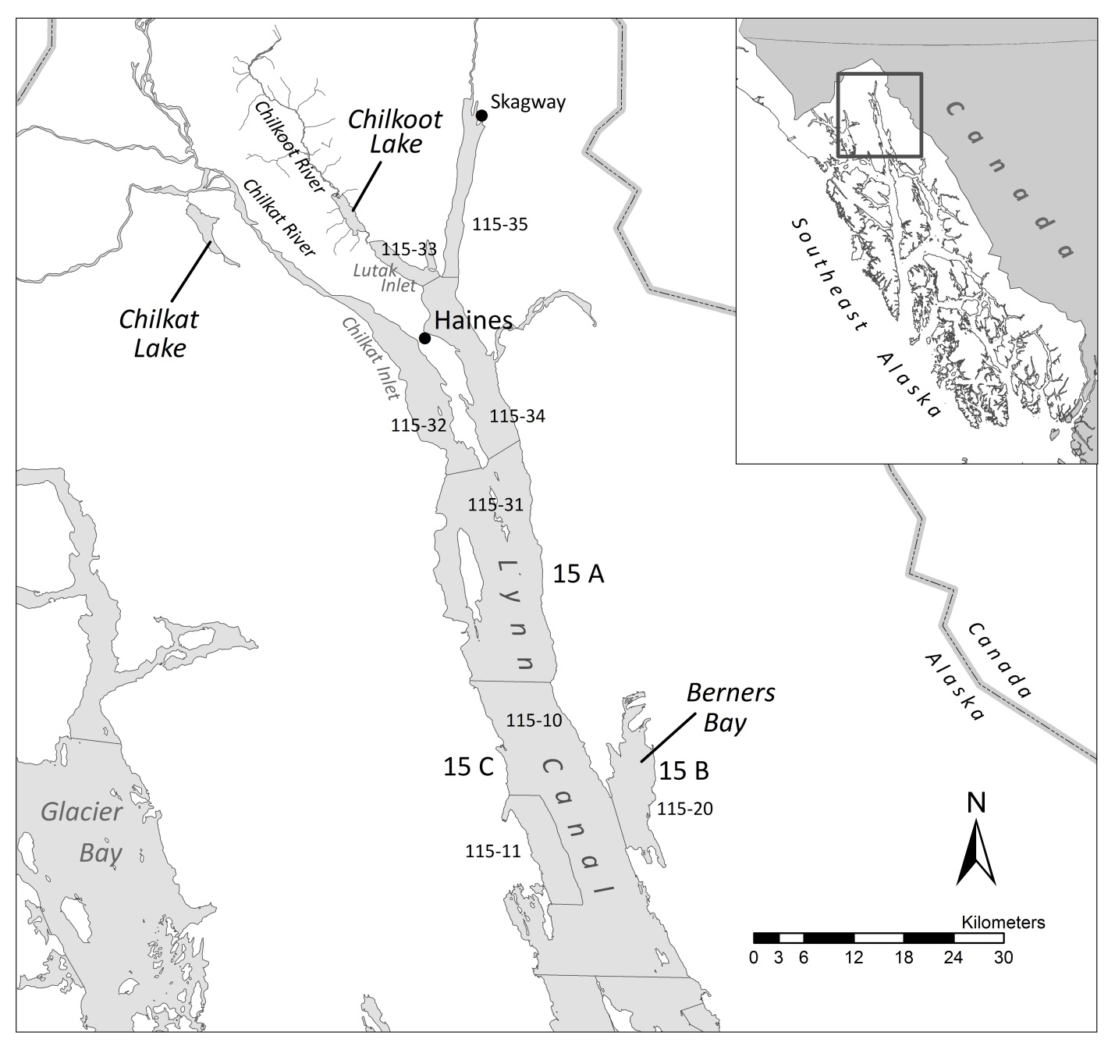

Figure 1.–Commercial fishing subdistrict and management boundary lines within District 15 in the Haines area, Southeast Alaska.



Figure 2.–Map showing Lutak Inlet, Chilkoot Lake, and the location of the limnology stations and salmon counting weir.

# Methods

## Data

### Harvest Estimates

Commercial harvest data for the District 15 commercial drift gillnet fishery in northern Lynn Canal was obtained from the ADF&G Southeast Alaska Integrated Fisheries Database. However, harvest from District 15 contains sockeye salmon from multiple stocks. Thus, visual scale pattern analysis (SPA) was used to determine stock composition of sockeye salmon harvested in the District 15 commercial drift gillnet fishery and estimate harvest of fish bound for Chilkoot Lake (Bachman et al. 2014). The general methods of stock apportionment using SPA have remained unchanged since the mid-1980s: escapement scale samples from 3 stocks of known origin, Chilkoot Lake, Chilkat Lake, and “other” (Chilkat River mainstem and Berners Bay stocks), were aged and compared to scale samples from the commercial fisheries, which were apportioned to these three stocks for each statistical week. Since total District 15 commercial drift gillnet harvest was not apportioned to a particular stock in years 1976 through 1983, the apportionment percentages from McPherson (1990) were reapplied to updated harvest from those years (Bednarski et al. 2017).

### Escapement Estimates

Sockeye salmon entering into Chilkoot Lake have been counted through a weir on the Chilkoot River, located downstream of the lake outlet, from 1976 through 2017 (Bergander 1989, 1990; Bachman and Kelley 1999; Bachman 2003; Bachman and Sogge 2006; Bednarski et al. 2017). The run has two components, an early and a late run, and these two components are currently managed as a single unit. The sockeye salmon weir counts have varied dramatically during these years, from 7,200 (1995) to 103,000 (1982) fish (Table 1, Figure 3). Weir counts have averaged 66,273 sockeye salmon between 1976 and 2016. Weir counts were low during the period, 1994 to 2000, and averaged a little over 30 thousand during this period. Escapement age compositions are based on annual scale samples taken at the weir and used to estimate escapement by age (Table 2).

The extremely low weir count in 1995 prompted ADF&G to verify the weir counts by conducting mark-recapture experiments on Chilkoot Lake sockeye salmon. The mark-recapture project was conducted annually from 1996 to 2004 and again in 2007, (Bachman and Kelley 1999, Bachman and Sogge 2006, Bachman and Eisenman *in prep*.). The mark recapture estimates were consistently higher than weir counts averaging 1.84 times the weir count (Table 1). Because spawning in Chilkoot Lake occurs primarily in beach spawning areas and in the remote upper reaches of the Chilkoot watershed, the second-event recovery is difficult and low tag recoveries have contributed to imprecise mark recapture estimates. Differences between mark recapture were not consistent enough for a calibration of the weir counts (Figure 4). Assessments of Chilkoot sockeye salmon escapements are based on weir counts, recognizing that they are likely conservative.

### Recruits from Parent Escapement by Age

Scale samples from commercial harvests and escapement were analyzed at the ADF&G salmon-aging laboratory in Douglas, Alaska. Age classes were designated by the European aging system where freshwater and saltwater years were separated by a period (e.g., 1.3 denoted a fish with 1 freshwater and 3 ocean years; Koo 1962). The weekly age distribution (the seasonal age distribution weighted by week) calculated using equations from Cochran (1977).

The recruits, by age, from parent escapements were estimated for the 1976 to 2010 brood years (Table 4). The recruits from brood year *y* and age *a* is the escapement and catch for age *a* in calendar year *y + a*.

 (1)

*Ra,y* is the recruits for age a and brood year *y, Ea,y+a* is the escapement by age a and calendar year *y+a*, and *Ca,y+a* is catch by age *a* and calendar year *y+a*.

Production for year classes 1976 through 2010 was estimated for each cohort as the sum of production at age over ages of the cohort:

 (2)

As of this writing, some of the older and rarer age class from the 2010 brood year had not yet returned and been enumerated. However, based on previous years, the incomplete age classes were estimated to represent less than 1% of the total brood year recruits and therefore we consider it unlikely that these will have a substantial influence on the results of our analysis.

## Stock-Recruitment Analysis

Hierarchical stock-recruitment model were fit to the Chilkoot Lake stock-recruit data for the 1976 to 2010 brood years. The stock-recruit models are Ricker type (Ricker 1975) and hierarchal terms included escapement density and a first order autoregressive term, with two models constructed: (1) a straight Ricker, with density dependence due to escapement; and (2) an autoregressive Ricker with density dependence due to escapement and autoregressive terms included. The significance of the relative fit of the alternative models was evaluated using the likelihood ratio test (Hilborn and Mangel 1997).

Model 1, Straight Ricker;

 (5)

Model 3, Autoregressive Ricker. The autoregressive Ricker model is the result of a first order (mean = 0, parameter  autoregressive process where observations are linearly related to the prior year observation (c.f. Noakes et al 1987).

 (6)

### Process Model

A hierarchical set of two stock-recruitment models were fit to the Chilkoot Lake stock-recruit data for calendar years 1976–2016. The stock-recruitment models were Ricker-type and hierarchical terms included density-dependent fry plants and a first order autoregressive (AR(1)) term. Returns *R* of Chilkoot lake sockeye salmon were modeled as a function of spawning escapement *S* in year *y* using a linearized Ricker (1954) spawner-recruit function with an AR lognormal process error with a lag of 1 year (Noakes et al. 1987),

. (3)

Returns for Model 2 were modeled using a linearized AR(1) Ricker (eq. 3), but an additional density-dependent fry term, *γ*, was included,

. (4)

Fry plants were from brood year *y* in year *y*+1 (Fy+1). In eq. 3 and 4, **  is the productivity parameter, ** is the inverse capacity parameter, * *is the AR lag-1 coefficient, and {} are the model residuals,

 (5)

In eq. 3, {} are independently and normally distributed process errors with standard deviation  Six initial returns (1970–1975) were modeled as draws from a common log normal distribution with parameters ln(*R*0) and  These returns were not linked to the escapement data in the spawner recruit relationship.

Age-at-maturity proportions  from year *y* and returning at ages 4–6 (ages 2–4 were combined and ages 6–8 were combined) were drawn from a common Dirichlet distribution that was implemented by generating independent random variables from the gamma distribution  and dividing each by their sum (Evans et al. 1993),

. (6)

Proportions of recruits at age, , (Gelman et al. 2004) were calculated as

, (7)

and implemented as a series of nested beta distributions, reflecting age-at-maturity central tendencies. The sum of the Dirichlet parameters, , is the inverse dispersion (*D*) of the Dirichlet distribution. A low value of *D* is reflective of a large amount of variability of age-at-maturity proportions *p* among brood years, whereas a high value of *D* indicates more consistency in *p* over time.

The abundance *N* of Chilkoot Lake sockeye salmon of age-*a* returning to spawn in calendar year *y* (*y* = 1976–2016) is the product of the age proportion scalar *p* and the total return (recruitment) *R* from year *y*-*a*,

. (8)

Total run abundance during calendar year *y* is the sum of abundance-at-age across ages,

. (9)

The spawning escapement count each calendar year, *Sy*, is the difference between total run abundance and the total District 15 Chilkoot Lake commercial harvest, *Hbelowy*,

 (10)

Annual commercial harvest was modeled as the product of the total run and annual harvest rate,

, (11)

drawn from a beta distribution (Appendix A.1).

## Model Fitting

Model fitting involves finding the values of population parameters that can plausibly result in the observed data. Using the package RJAGS (Plummer 2016) within R (R Core Team 2016), Markov Chain Monte Carlo (MCMC) methods were employed to provide a more realistic assessment of uncertainty than is possible with traditional stock-recruit methods.

The significance of the fit of the alternative models (Model 1: l linearized AR(1) Ricker; Model 2: linearized AR(1) Ricker with density-dependent fry plants) were evaluated using the deviance information criterion (DIC; Spiegelhalter et al. 2002), a Bayesian version or generalization of the Akaike information criterion (AIC; Akaike 1973) and related to the Bayesian (or Schwarz) information criterion (BIC; Schwarz 1978). Similar to both the AIC and BIC, it trades off a measure of model adequacy against a measure of complexity. Models receiving a DIC within 1-2 of the ‘best’ model deserve consideration, while models within 3–7 of the ‘best’ model have considerably less support (Spiegelhalter et al. 2002).

### Prior Distributions

For all unknowns in the model, Bayesian analysis requires that prior probabilities be specified. Most prior distributions in this model were uninformative with a few exceptions (Table 4). Normal priors with mean 0, extremely large variances, and constrained to be positive were used for *β* (Millar 2002). Log transformed initial recruitments *R*1970*-R*1976 (those with no linked spawner abundance) were modeled as drawn from a common normal distribution with mean ln(*R*0) and variance . A flat prior on the standard deviation of log initial brood year returns, , caused computational disruptions during MCMC sampling so it was changed to a slightly informative inverse gamma prior. Fleischman et al. (2013) found that an informative prior on  may have a large effect on the posterior of  and the initial values of *Ry*, but negligible effects on key model quantities.

Table 4.–Prior distributions for model parameters. Where “Uniform” is in quotes, a normal distribution with mean 0 and large variance was used in the actual RJAGS code to prevent computational disruptions during MCMC sampling.

|  |  |  |
| --- | --- | --- |
| **Parameter** | **RJAGS coding** | **Prior** |
| ln(**) | lnalpha | ln(**) ~ “Uniform” (0,3) |
| ** | beta | * *~ “Uniform” (0,∞) |
| *R* | sigma.R | ~gamma(0.001,0.001) |
| ** | phi | * *~ “Uniform” (-0.98,0.98); |
| ** | log.resid.0 |  |
| *D* | D |  |
| ln(*R*0) | mean.log.R0 | ln(*R*0) ~ “Uniform” (∞,∞) |
| *R0* | sigma.R0 | ~gamma(0.001,0.001) |
| *γ* | gam | *γ *~ “Uniform” (-0.98,0.98) |
| ln(*R*1):ln(*R*7) | log.R[1:7] | ~Normal(ln(*R*0), ) |

### Sampling from the Posterior Distribution

MCMC methods were used to generate the joint posterior probabilities of the unknown quantities using the package RJAGS (Plummer 2016) with R. Three Markov chains were initiated. After a 10,000 sample burn-in period was discarded, 3,000 samples (1,000,000 iterations, thinned by 1000; 1000 samples per chain) MCMC updates were retained for analysis to estimate posterior medians, standard deviations, and percentiles. The diagnostic tools of the package RJAGS (Plummer 2016) such as time series and density plots, the Gelman Rubin convergence diagnostics (Brooks and Gelman 1998), autocorrelation plots, and Monte Carlo standard errors (e.g. MC error should be less than 5% of the sample standard deviation) (Toft et al. 2007) were used to assess mixing and convergence. No major problems were encountered. Interval estimates were constructed from the percentiles of the posterior distribution.

### Reference Points, Optimal Yield Profiles, Overfishing Profiles, Optimal Recruitment Profiles, and Sustained Yield

Reference points were calculated for each individual MCMC sample. Spawning abundance at maximum sustained yield (MSY), *S*MSY, was approximated by (Hilborn 1985),

 (18a)

and approximated based on Peterman et al. (2000),

 (18b)

where to correct for the difference between the median and the mean of a lognormal error distribution from an AR(1) process (Parken et al. 2006). Sustained yield at a specified level of *S* was obtained by subtracting spawning escapement from recruitment,

 (19)

Spawning escapement at peak return, *S*MSR, was calculated as 1/ and equilibrium spawning abundance (recruitment exactly replaces spawners) as,

. (20)

Harvest rate leading to MSY, *U*MSY, was approximated by (Hilborn 1985),

, (21a)

and approximated based on Peterman et al. (2000),

 (21b)

Optimal yield probabilities are the probabilities that a given level of spawning escapement (*S*) will produce average yields exceeding X% of MSY. These probabilities are created by calculating expected sustained yield, *YS*, at incremental levels of *S* (0 to 300,000 by 2,500) for each MCMC sample using equation 19, and then comparing *YS* with X% (80%, 90%) of the value of MSY for the sample. The proportion (*P*OY) of samples that fit the criteria: *YS* > X% of MSY is an estimate of the desired probability. Optimal yield profiles are plots of *P*OY versus *S* (Fleischman et al. 2013).

Overfishing probability profiles show the probability of overfishing the stock such that sustained yield is reduced to less than a fraction (80%, 90%) of MSY. To produce the overfishing probability profiles, expected sustained yield (eq. 19) at multiple incremental levels of *S* (0 to 300,000 by 2,500) are calculated for each MCMC sample. Then, the number of MCMC samples for which *YS*is less than X% of MSY and *S* is less than *S*MSY is tabulated. Overfishing probability profiles are then a plot of the fraction of samples in which this condition occurred versus *S* (Bernard and Jones III 2010).

Optimal recruitment profiles are the probabilities that a given spawning escapement (*S*) will produce average recruitments (*R*) exceeding X% (80%, 90%) of maximum sustained recruitment (MSR). These probabilities are created by calculating *R* from

 (23)

at incremental levels of *S* (0 to 300,000 by 2,500) for each MCMC sample, then comparing *R* with X% of the value of MSR for that sample. The proportion *PR* of samples in which *R* exceeded X% of MSR is an estimate of the desired probability. Optimal recruitment profiles are then a plot of *PR* versus *S* (Fleischman et al. 2013).

Expected sustained yield is the number of fish in the expected recruitment over and above that needed to replace the spawners (Fleischman et al. 2011).

# Results

Appendix A2 summarizes empirical estimates of harvest, age composition, escapement, and escapement indices for Chilkoot Lake sockeye salmon.

### Model Comparison

A hierarchical set of two stock-recruitment models were fit to the Chilkoot Lake stock-recruit data for brood years 1976–2016. The stock-recruitment models were Ricker-type and hierarchical terms included a first order autoregressive term. The effect of the fry plant term (*γ* = -5.81E-08; Table 5) was to correct the increased production due to the fry plants and to provide an unbiased estimate of the wild stock MSY escapement goal. The best model based on the fit criteria (i.e., minimum DIC) was the autoregressive Ricker with fry plants, but the difference between the best fit model fit and the autoregressive Ricker model fit was negligible (∆0.31) and the 95% credibility intervals on the density-dependent fry term, *γ*, included zero (-2.74E-07, 1.69E-07) and thus the term was non-significant. Therefore, the autoregressive Ricker model was considered the most meaningful biological model.

Table 5.–Results of model fit to the escapement-recruit data for brood years 1976 to 2010. Estimated parameters, reference points, and measures of fit (DIC). The lower and upper bound on the *S*MSY and *S*MSY(Peterman) reference points define the 2.5th and 97.5th percentiles which represent the 95% credibility intervals for the parameters.

|  |  |
| --- | --- |
| Parameters | Autoregressive Ricker |
| *α* | 2.89 |
| *β* | 5.11E-06 |
| ** | 0.49 |
| *S*MSY | 101,425 |
| Lower | 65,484 |
| Upper | 308,889 |
| *S*MSY(Peterman) | 101,626 |
| Lower | 65,520 |
| Upper | 311,043 |
| Harvest Rate | 0.73 |
| Harvest Rate Peterman | 0.73 |
| DIC | 3090.20 |

### Abundance, Time-Varying Productivity, Harvest Rates, and Age-at-Maturity

Reconstructed total run abundance (*N*) for the autoregressive Ricker model had CVs from 5% to 14% (Figure 3; Table 6). The years with higher uncertainty corresponded to years with missing

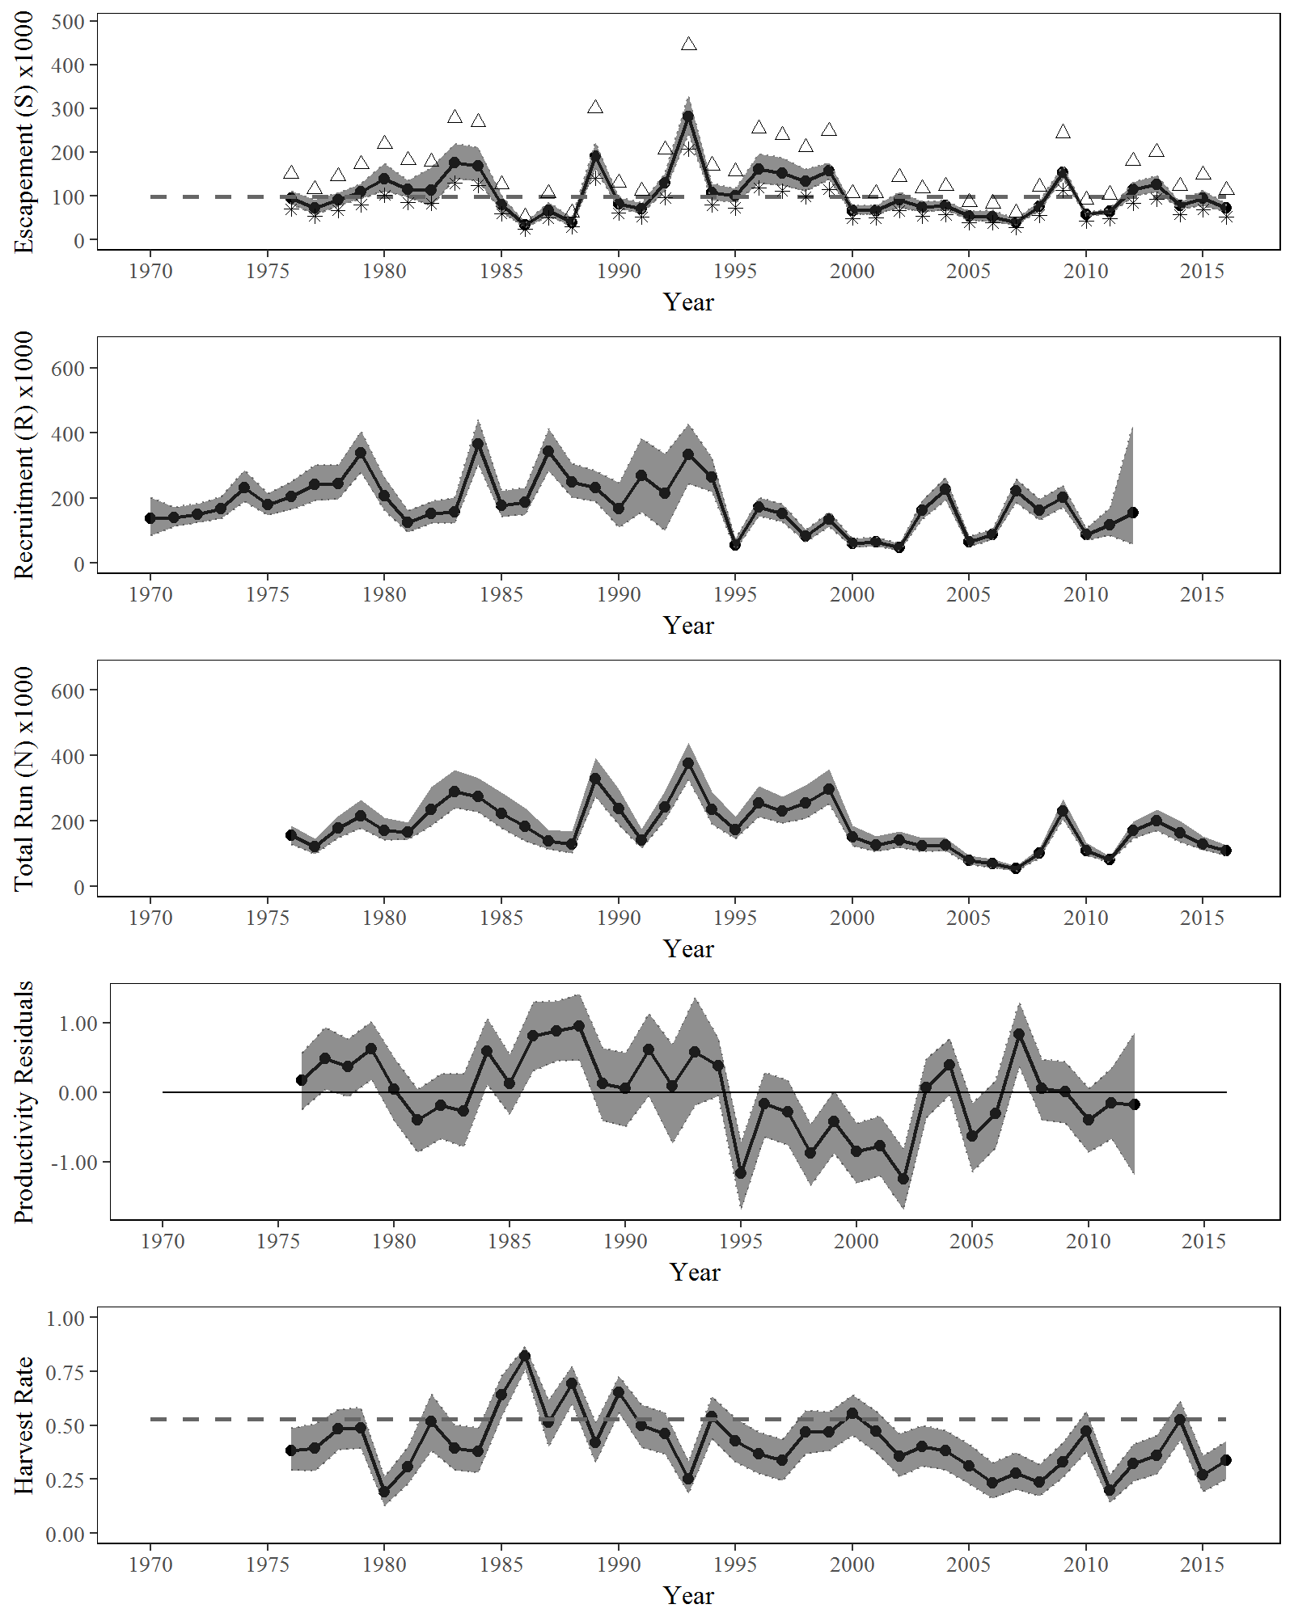

Figure 3.–Point estimates (posterior medians; solid lines) and 95% credibility intervals (shaded areas) of spawning escapement with the two indices of escapement (weir (stars); mark–recapture (open triangles)), recruitment by brood year, total run abundance, Ricker productivity residuals, and harvest rate from a state-space model of Chilkoot Lake sockeye salmon, 1976–2016. Posterior medians of *S*MSY and *U*MSY are plotted as dashed horizontal reference lines.

Table 1.–Estimated total harvest of Chilkoot Lake sockeye salmon and harvest proportions by age, 1976–2016.

|  |  |  |  |  |  |  |  |  |
| --- | --- | --- | --- | --- | --- | --- | --- | --- |
|  |  | **Harvest proportion by age** | | |  |  |  |  |
| **Year** | **Harvest** | **Age 2** | **Age 3** | **Age 4** | **Age 5** | **Age 6** | **Age 7** | **Age 8** |
| 1976a | 58,765 | 0.00 | 0.00 | 0.05 | 0.70 | 0.25 | 0.00 | 0.00 |
| 1977a | 41,477 | 0.00 | 0.00 | 0.03 | 0.71 | 0.26 | 0.00 | 0.00 |
| 1978a | 89,558 | 0.00 | 0.00 | 0.04 | 0.63 | 0.33 | 0.00 | 0.00 |
| 1979a | 115,995 | 0.00 | 0.00 | 0.03 | 0.84 | 0.13 | 0.01 | 0.00 |
| 1980a | 31,267 | 0.00 | 0.00 | 0.02 | 0.53 | 0.44 | 0.00 | 0.00 |
| 1981a | 48,420 | 0.00 | 0.00 | 0.03 | 0.47 | 0.50 | 0.01 | 0.00 |
| 1982a | 127,174 | 0.00 | 0.00 | 0.01 | 0.44 | 0.54 | 0.00 | 0.00 |
| 1983a | 124,180 | 0.00 | 0.00 | 0.02 | 0.45 | 0.53 | 0.00 | 0.00 |
| 1984 | 99,592 | 0.00 | 0.00 | 0.00 | 0.70 | 0.30 | 0.00 | 0.00 |
| 1985 | 131,091 | 0.00 | 0.00 | 0.00 | 0.33 | 0.66 | 0.00 | 0.00 |
| 1986 | 168,006 | 0.00 | 0.00 | 0.01 | 0.37 | 0.61 | 0.00 | 0.00 |
| 1987 | 69,900 | 0.00 | 0.00 | 0.01 | 0.60 | 0.39 | 0.00 | 0.00 |
| 1988 | 76,883 | 0.00 | 0.00 | 0.03 | 0.46 | 0.51 | 0.00 | 0.00 |
| 1989 | 156,160 | 0.00 | 0.00 | 0.00 | 0.68 | 0.32 | 0.00 | 0.00 |
| 1990 | 149,377 | 0.00 | 0.00 | 0.01 | 0.45 | 0.54 | 0.00 | 0.00 |
| 1991 | 60,721 | 0.00 | 0.00 | 0.01 | 0.39 | 0.60 | 0.01 | 0.00 |
| 1992 | 113,146 | 0.00 | 0.00 | 0.01 | 0.46 | 0.53 | 0.00 | 0.00 |
| 1993 | 103,531 | 0.00 | 0.00 | 0.02 | 0.32 | 0.66 | 0.00 | 0.00 |
| 1994 | 126,852 | 0.00 | 0.00 | 0.01 | 0.55 | 0.41 | 0.02 | 0.00 |
| 1995 | 68,737 | 0.00 | 0.00 | 0.04 | 0.46 | 0.50 | 0.00 | 0.00 |
| 1996 | 99,677 | 0.00 | 0.00 | 0.02 | 0.48 | 0.50 | 0.00 | 0.00 |
| 1997 | 73,761 | 0.00 | 0.00 | 0.04 | 0.39 | 0.57 | 0.00 | 0.00 |
| 1998 | 112,630 | 0.00 | 0.00 | 0.02 | 0.68 | 0.30 | 0.00 | 0.00 |
| 1999 | 149,410 | 0.00 | 0.00 | 0.01 | 0.46 | 0.52 | 0.00 | 0.00 |
| 2000 | 78,265 | 0.00 | 0.00 | 0.02 | 0.12 | 0.85 | 0.00 | 0.00 |
| 2001 | 60,183 | 0.00 | 0.00 | 0.03 | 0.76 | 0.19 | 0.02 | 0.00 |
| 2002 | 47,332 | 0.00 | 0.00 | 0.03 | 0.45 | 0.52 | 0.00 | 0.00 |
| 2003 | 49,955 | 0.00 | 0.00 | 0.02 | 0.28 | 0.70 | 0.00 | 0.00 |
| 2004 | 51,110 | 0.00 | 0.00 | 0.05 | 0.69 | 0.25 | 0.01 | 0.00 |
| 2005 | 22,852 | 0.00 | 0.00 | 0.03 | 0.36 | 0.62 | 0.00 | 0.00 |
| 2006 | 15,979 | 0.00 | 0.00 | 0.08 | 0.53 | 0.38 | 0.01 | 0.00 |
| 2007 | 14,208 | 0.00 | 0.00 | 0.02 | 0.64 | 0.33 | 0.01 | 0.00 |
| 2008 | 22,156 | 0.00 | 0.00 | 0.04 | 0.82 | 0.14 | 0.00 | 0.00 |
| 2009 | 85,551 | 0.00 | 0.00 | 0.01 | 0.51 | 0.48 | 0.00 | 0.00 |
| 2010 | 48,079 | 0.00 | 0.00 | 0.01 | 0.24 | 0.74 | 0.00 | 0.00 |
| 2011 | 15,599 | 0.00 | 0.00 | 0.03 | 0.62 | 0.35 | 0.00 | 0.00 |
| 2012 | 54,884 | 0.00 | 0.00 | 0.08 | 0.69 | 0.22 | 0.00 | 0.00 |
| 2013 | 75,588 | 0.00 | 0.00 | 0.03 | 0.53 | 0.44 | 0.00 | 0.00 |
| 2014 | 81,502 | 0.00 | 0.00 | 0.04 | 0.64 | 0.31 | 0.01 | 0.00 |
| 2015 | 33,085 | 0.00 | 0.00 | 0.02 | 0.32 | 0.66 | 0.00 | 0.00 |
| 2016 | 35,991 | 0.00 | 0.00 | 0.05 | 0.55 | 0.40 | 0.01 | 0.00 |

a. McPherson 1990.

Table 2.–Expanded Chilkoot Lake sockeye salmon escapement estimates (1976-2016); mark–recapture (MR)

|  |  |  |  |  |  |  |  |  |  |  |  |  |  |  |  |  |  |  |
| --- | --- | --- | --- | --- | --- | --- | --- | --- | --- | --- | --- | --- | --- | --- | --- | --- | --- | --- |
|  |  |  |  | **Escapement proportion by age** | | | | | | |  | |  | |  | |  | |
| **Year** | **DIDSON** | **MR** | **Weir** | **Age 2** | | **Age 3** | | **Age 4** | | **Age 5** | | | **Age 6** | | **Age 7** | | **Age 8** | |
| 1976a | NA | NA | 69,729 | 0.00 | 0.00 | | 0.06 | | 0.65 | | | 0.29 | | 0.00 | | 0.00 | |
| 1977a | NA | NA | 50,363 | 0.00 | 0.00 | | 0.04 | | 0.77 | | | 0.19 | | 0.00 | | 0.00 | |
| 1978a | NA | NA | 67,528 | 0.00 | 0.00 | | 0.10 | | 0.66 | | | 0.25 | | 0.00 | | 0.00 | |
| 1979a | NA | NA | 80,588 | 0.00 | 0.00 | | 0.01 | | 0.71 | | | 0.28 | | 0.00 | | 0.00 | |
| 1980a | NA | NA | 101,135 | 0.00 | 0.00 | | 0.02 | | 0.64 | | | 0.33 | | 0.00 | | 0.00 | |
| 1981a | NA | NA | 84,097 | 0.00 | 0.00 | | 0.00 | | 0.59 | | | 0.41 | | 0.00 | | 0.00 | |
| 1982 | NA | NA | 86,213 | 0.00 | 0.01 | | 0.04 | | 0.60 | | | 0.36 | | 0.00 | | 0.00 | |
| 1983 | NA | NA | 134,601 | 0.00 | 0.01 | | 0.06 | | 0.65 | | | 0.28 | | 0.00 | | 0.00 | |
| 1984 | NA | NA | 123,190 | 0.00 | 0.00 | | 0.03 | | 0.76 | | | 0.21 | | 0.00 | | 0.00 | |
| 1985 | NA | NA | 58,335 | 0.00 | 0.01 | | 0.04 | | 0.49 | | | 0.46 | | 0.00 | | 0.00 | |
| 1986 | NA | NA | 23,947 | 0.00 | 0.00 | | 0.05 | | 0.29 | | | 0.66 | | 0.00 | | 0.00 | |
| 1987 | NA | NA | 48,972 | 0.00 | 0.01 | | 0.05 | | 0.59 | | | 0.34 | | 0.00 | | 0.00 | |
| 1988 | NA | NA | 27,722 | 0.00 | 0.00 | | 0.01 | | 0.38 | | | 0.61 | | 0.00 | | 0.00 | |
| 1989 | NA | NA | 141,475 | 0.00 | 0.00 | | 0.01 | | 0.71 | | | 0.28 | | 0.00 | | 0.00 | |
| 1990 | NA | NA | 60,230 | 0.00 | 0.00 | | 0.02 | | 0.42 | | | 0.56 | | 0.00 | | 0.00 | |
| 1991 | NA | NA | 51,138 | 0.00 | 0.00 | | 0.02 | | 0.55 | | | 0.42 | | 0.00 | | 0.00 | |
| 1992 | NA | NA | 95,880 | 0.00 | 0.00 | | 0.01 | | 0.42 | | | 0.57 | | 0.00 | | 0.00 | |
| 1993 | NA | NA | 212,757 | 0.00 | 0.00 | | 0.04 | | 0.41 | | | 0.55 | | 0.00 | | 0.00 | |
| 1994 | NA | 153,540 | 86,385 | 0.00 | 0.00 | | 0.02 | | 0.60 | | | 0.37 | | 0.01 | | 0.00 | |
| 1995 | NA | 184,541 | 61,783 | 0.00 | 0.00 | | 0.04 | | 0.46 | | | 0.49 | | 0.00 | | 0.00 | |
| 1996b | NA | 262,852 | NA | NA | NA | | NA | | NA | | | NA | | NA | | NA | |
| 1997b | NA | 238,803 | NA | NA | NA | | NA | | NA | | | NA | | NA | | NA | |
| 1998b | NA | 211,114 | NA | NA | NA | | NA | | NA | | | NA | | NA | | NA | |
| 1999 | NA | 240,002 | 134,048 | 0.00 | 0.00 | | 0.01 | | 0.40 | | | 0.59 | | 0.00 | | 0.00 | |
| 2000 | NA | 132,687 | 47,077 | 0.00 | 0.00 | | 0.02 | | 0.14 | | | 0.84 | | 0.00 | | 0.00 | |
| 2001 | NA | 105,064 | 53,239 | 0.00 | 0.00 | | 0.03 | | 0.79 | | | 0.16 | | 0.02 | | 0.00 | |
| 2002 | NA | 148,465 | 65,611 | 0.00 | 0.00 | | 0.03 | | 0.45 | | | 0.52 | | 0.00 | | 0.00 | |
| 2003 | NA | 116,891 | 55,516 | 0.00 | 0.00 | | 0.03 | | 0.30 | | | 0.67 | | 0.00 | | 0.00 | |
| 2004 | NA | 118,795 | 83,534 | 0.00 | 0.00 | | 0.04 | | 0.65 | | | 0.30 | | 0.01 | | 0.00 | |
| 2005 | NA | 89,072 | 32,098 | 0.00 | 0.00 | | 0.04 | | 0.39 | | | 0.57 | | 0.00 | | 0.00 | |
| 2006 | NA | 91,439 | 38,850 | 0.00 | 0.00 | | 0.05 | | 0.62 | | | 0.32 | | 0.00 | | 0.00 | |
| 2007 | NA | 59,884 | 27,915 | 0.00 | 0.00 | | 0.07 | | 0.48 | | | 0.45 | | 0.00 | | 0.00 | |
| 2008 | 74,919 | 119,808 | NA | 0.00 | 0.00 | | 0.05 | | 0.82 | | | 0.12 | | 0.00 | | 0.00 | |
| 2009 | 153,033 | 285,218 | NA | 0.00 | 0.00 | | 0.03 | | 0.71 | | | 0.25 | | 0.00 | | 0.00 | |
| 2010 | 61,906 | 72,318 | NA | 0.00 | 0.01 | | 0.03 | | 0.37 | | | 0.59 | | 0.00 | | 0.00 | |
| 2011 | 63,628 | 109,335 | NA | 0.00 | 0.00 | | 0.09 | | 0.61 | | | 0.29 | | 0.00 | | 0.00 | |
| 2012 | 121,810 | 171,924 | NA | 0.00 | 0.01 | | 0.05 | | 0.77 | | | 0.17 | | 0.00 | | 0.00 | |
| 2013 | 116,300 | 224,516 | NA | 0.00 | 0.00 | | 0.08 | | 0.49 | | | 0.43 | | 0.00 | | 0.00 | |
| 2014 | 70,470 | 212,201 | NA | 0.00 | 0.01 | | 0.02 | | 0.72 | | | 0.25 | | 0.01 | | 0.00 | |
| 2015 | 175,874 | 124,892 | NA | 0.00 | 0.00 | | 0.04 | | 0.29 | | | 0.66 | | 0.00 | | 0.00 | |
| 2016 | 88,513 | 96,148 | NA | 0.00 | 0.00 | | 0.04 | | 0.60 | | | 0.36 | | 0.00 | | 0.00 | |

a.The weir was not operated in 1996, 1997, or 1998.

Table 3.–Number of enhanced sockeye salmon fry in Chilkoot Lake for release years 1989 to 2003 (Eggers et al. 2010). The stocked fry were incubated as eggs in the hatchery and released as fry into Chilkoot Lake in the spring. The number of fry that emerged in the spring each year from incubation boxes was estimated from the number of eggs seeded in incubation boxes minus the dead eggs counted in the spring.

|  |  |  |  |  |  |
| --- | --- | --- | --- | --- | --- |
| **Brood Year** | **Release Year** | **Stocked fry (thermal marked)a** | **Stocked fry (unmarked)** | **Incubation fry boxb** | **Total enhanced fry** |
| 1988 | 1989 | 0 | 0 | 15,094 | 15,094 |
| 1989 | 1990 | 0 | 0 | 300,127 | 300,127 |
| 1990 | 1991 | 0 | 0 | 388,000 | 388,000 |
| 1991 | 1992 | 0 | 0 | 201,753 | 201,753 |
| 1992 | 1993 | 0 | 0 | 594,000 | 594,000 |
| 1993 | 1994 | 4,817,929 | 0 | 550,700 | 5,368,629 |
| 1994 | 1995 | 2,334,264 | 0 | 289,500 | 2,623,764 |
| 1995 | 1996 | 2,691,311 | 6,138 | 572,350 | 3,269,799 |
| 1996 | 1997 | 3,038,171 | 0 | 96,500 | 3,134,671 |
| 1997 | 1998 | 0 | 0 | 437,950 | 437,950 |
| 1998 | 1999 | 0 | 0 | 0 | 0 |
| 1999 | 2000 | 0 | 0 | 0 | 0 |
| 2000 | 2001 | 2,743,374 | 0 | 0 | 2,743,374 |
| 2001 | 2002 | 0 | 0 | 0 | 0 |
| 2002 | 2003 | 0 | 0 | 49,500 | 49,500 |

aNumber of stocked fry updated from ADF&G Mark, Tag, and Age Laboratory website 20 June 2012.

bNumber of unmarked fry from incubation boxes from Eggers et al. 2010 (Table 1; FMS 10-05).

Table 6.–Annual abundance estimates for Chilkoot Lake sockeye salmon obtained by fitting a state-space model to data for calendar years 1976–2016. Point estimates are posterior medians and CVs are posterior standard deviations divided by posterior means. Recruitment values are listed by brood year.

|  |  |  |  |  |  |  |
| --- | --- | --- | --- | --- | --- | --- |
|  |  |  |  | Coefficients of Variations | |  |
| Year | Total Run | Escapement | Return | Total Run | Escapement | Return |
| 1970 |  |  | 137,316 |  |  | 0.22 |
| 1971 |  |  | 138,731 |  |  | 0.11 |
| 1972 |  |  | 149,647 |  |  | 0.10 |
| 1973 |  |  | 166,317 |  |  | 0.10 |
| 1974 |  |  | 230,729 |  |  | 0.10 |
| 1975 |  |  | 178,517 |  |  | 0.10 |
| 1976 | 154,759 | 94,767 | 203,002 | 0.09 | 0.08 | 0.11 |
| 1977 | 120,150 | 72,454 | 240,751 | 0.10 | 0.12 | 0.12 |
| 1978 | 177,258 | 91,665 | 243,163 | 0.10 | 0.08 | 0.11 |
| 1979 | 213,916 | 109,033 | 337,173 | 0.10 | 0.08 | 0.10 |
| 1980 | 171,241 | 138,874 | 205,394 | 0.10 | 0.11 | 0.12 |
| 1981 | 166,555 | 114,918 | 125,111 | 0.08 | 0.08 | 0.13 |
| 1982 | 235,682 | 112,566 | 152,666 | 0.13 | 0.19 | 0.11 |
| 1983 | 289,335 | 175,171 | 155,779 | 0.10 | 0.11 | 0.13 |
| 1984 | 273,751 | 169,155 | 365,918 | 0.10 | 0.11 | 0.09 |
| 1985 | 223,643 | 80,025 | 177,253 | 0.12 | 0.12 | 0.12 |
| 1986 | 182,155 | 32,763 | 187,376 | 0.14 | 0.08 | 0.11 |
| 1987 | 138,713 | 67,242 | 343,729 | 0.11 | 0.12 | 0.09 |
| 1988 | 129,464 | 39,289 | 248,168 | 0.13 | 0.12 | 0.11 |
| 1989 | 328,466 | 190,175 | 231,251 | 0.09 | 0.08 | 0.10 |
| 1990 | 236,104 | 82,037 | 166,363 | 0.12 | 0.08 | 0.21 |
| 1991 | 141,265 | 70,541 | 268,761 | 0.11 | 0.08 | 0.22 |
| 1992 | 241,875 | 129,999 | 213,594 | 0.10 | 0.08 | 0.28 |
| 1993 | 376,584 | 281,305 | 333,692 | 0.08 | 0.08 | 0.14 |
| 1994 | 234,189 | 107,365 | 263,850 | 0.11 | 0.09 | 0.10 |
| 1995 | 174,126 | 99,241 | 54,392 | 0.10 | 0.08 | 0.16 |
| 1996 | 255,615 | 161,020 | 170,871 | 0.10 | 0.11 | 0.09 |
| 1997 | 228,785 | 151,191 | 151,164 | 0.09 | 0.11 | 0.09 |
| 1998 | 253,565 | 133,811 | 81,823 | 0.10 | 0.10 | 0.12 |
| 1999 | 296,766 | 156,537 | 133,277 | 0.09 | 0.06 | 0.08 |
| 2000 | 149,615 | 66,770 | 59,773 | 0.11 | 0.07 | 0.11 |
| 2001 | 126,445 | 66,897 | 65,214 | 0.09 | 0.08 | 0.10 |
| 2002 | 140,668 | 90,054 | 48,135 | 0.09 | 0.10 | 0.11 |
| 2003 | 124,193 | 74,104 | 160,581 | 0.09 | 0.08 | 0.09 |
| 2004 | 125,953 | 77,162 | 225,809 | 0.08 | 0.07 | 0.08 |
| 2005 | 78,435 | 53,820 | 64,638 | 0.09 | 0.10 | 0.12 |
| 2006 | 68,537 | 52,341 | 87,719 | 0.10 | 0.12 | 0.09 |
| 2007 | 54,114 | 38,855 | 220,408 | 0.08 | 0.08 | 0.08 |
| 2008 | 100,740 | 76,643 | 161,408 | 0.07 | 0.07 | 0.10 |
| 2009 | 230,761 | 154,202 | 201,367 | 0.07 | 0.05 | 0.09 |
| 2010 | 109,848 | 57,719 | 86,419 | 0.09 | 0.05 | 0.11 |
| 2011 | 81,821 | 65,333 | 117,568 | 0.05 | 0.04 | 0.18 |
| 2012 | 169,313 | 114,024 | 154,752 | 0.08 | 0.07 | 0.56 |
| 2013 | 200,024 | 126,732 |  | 0.08 | 0.07 |  |
| 2014 | 164,112 | 77,737 |  | 0.10 | 0.05 |  |
| 2015 | 129,403 | 93,986 |  | 0.08 | 0.09 |  |
| 2016 | 108,283 | 71,703 |  | 0.08 | 0.07 |  |

escapement data (DIDSON; 1976–2007), missing escapement indices (weir or mark–recapture), and/or missing age composition data (1996–1998; Table 6; Appendix A2). Excluding the first initial returns, reconstructed brood year recruitment had CVs from 8% to 56%. The Ricker recruitment residuals (productivity residuals) in Figure 3 are deviations in recruitment from that predicted by the Ricker S–R relationship, reflecting time-varying changes in productivity after controlling for density-dependent effects. Productivity residuals were spread around 0 across years, indicating a good model fit and *σ*R was 0.55 (95% CI: 0.43–0.74) (Table 7). Median harvest rates (*U*MSY) ranged from 0.37 to 0.71 (Figure 3) and ranged from 0.37 to 0.70 for *U*MSY(Peterman). Chilkoot Lake sockeye salmon matured at ages 2– 4 (mean **4; 1%–8%), age-5 (mean **5; 36%–72%), and ages 6–8 (mean **6; 23% to 63%). These proportions have fluctuated moderately from brood year to brood year (Figure 4; top panel). Chilkoot Lake sockeye salmon are mainly composed of age–5 (1.3, 2.2) and age–6 (2.3) fish (Table 8). Age compositions have also fluctuated from year to year (Figure 4; middle and bottom panel).

Table 7.–Model parameter estimates for Chilkoot Lake for calendar years 1976–2016. Posterior medians are point estimates; 2.5th and 97.5th percentiles define 95% credibility intervals for the parameters. Parameter definitions are in the *Methods* section. Point estimates are posterior medians and CVs are posterior standard deviations divided by posterior means.

|  |  |  |  |  |
| --- | --- | --- | --- | --- |
| Parameter | 2.5th percentile | Median | 97.5th percentile | CV |
| ** | 3.29 | 8.41 | 49.89 | 0.28 |
| ln(**) | 1.19 | 2.13 | 3.91 | 0.24 |
| ** | 3.31E-06 | 1.40E-05 | 2.48E-05 | 0.35 |
| ** | 0.28 | 0.58 | 0.88 | 0.42 |
| **R | 0.72 | 0.97 | 1.86 | 0.14 |
| *S*EQ | 165,943 | 239,069 | 555,984 | 0.42 |
| *S*MSR | 108,227 | 183,490 | 527,649 | 0.58 |
| *S*MSY | 32,306 | 52,585 | 175,604 | 0.43 |
| *U*MSY | 0.37 | 0.53 | 0.71 | 0.16 |
| *S*MSY(Peterman) | 66,447 | 97,497 | 232,408 | 0.43 |
| *U*MSY(Peterman) | 0.37 | 0.54 | 0.70 | 0.16 |
| D | 20.50 | 32.45 | 51.78 | 0.24 |
| ** | 0.03 | 0.04 | 0.06 | 0.15 |
| ** | 0.51 | 0.54 | 0.57 | 0.03 |
| ** | 0.38 | 0.41 | 0.45 | 0.04 |
| *q*m-r | 1.46 | 1.58 | 1.72 | 0.04 |
| *q*weir | 0.65 | 0.74 | 0.83 | 0.06 |

Note: The CVs for the reference points *S*EQ, *S*MSR, *S*MSY, and *S*MSY(Peterman) were calculated as (97.5th percentile-2.5th percentile)/3.92 / posterior median point estimate. If the posterior median is approximately normal, then the lower and upper bound of the 95% credibility are both ~1.96 x standard errors from the median point estimate.

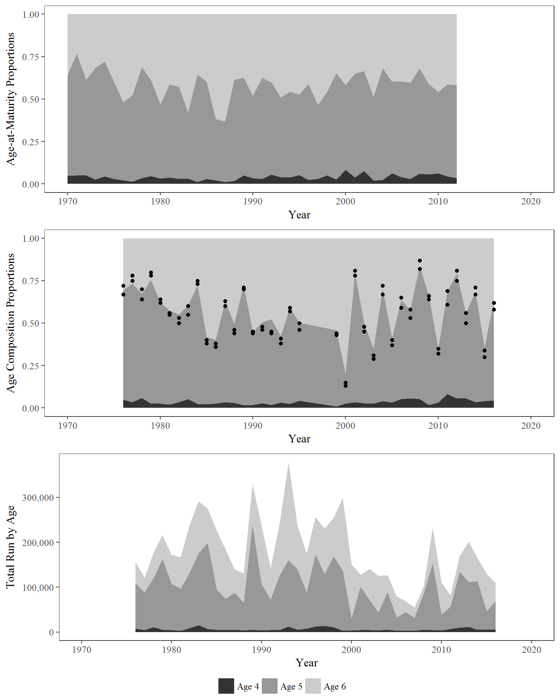

Figure 4.–Estimated age-at-maturity proportions by brood year (1970–2012; top), age composition proportions by calendar year (1976–2016; middle), and total run by age (bottom), from a state-space model fitted to data from Chilkoot Lake sockeye salmon. Top and middle figures are area graphs in which distance between lines represent age proportions. Dots in the middle plot are data-based estimates of age composition from Appendix A2.

Table 8.–Total run abundance by age-class obtained by fitting a state-space model to data from Chilkoot Lake sockeye salmon for calendar years 1976–2016. Point estimates are posterior medians and CVs are posterior standard deviations divided by posterior means.

|  |  |  |  |  |  |  |
| --- | --- | --- | --- | --- | --- | --- |
|  |  |  |  | Coefficients of Variations | | |
| Year | Age-4 | Age-5 | Age-6 | Age-4 | Age-5 | Age-6 |
| 1976 | 7,220 | 99,708 | 47,244 | 0.40 | 0.11 | 0.17 |
| 1977 | 3,760 | 84,142 | 31,817 | 0.48 | 0.12 | 0.18 |
| 1978 | 9,859 | 109,095 | 57,578 | 0.38 | 0.12 | 0.16 |
| 1979 | 4,889 | 155,475 | 52,417 | 0.54 | 0.12 | 0.18 |
| 1980 | 4,068 | 101,874 | 64,302 | 0.55 | 0.12 | 0.15 |
| 1981 | 2,757 | 92,507 | 70,848 | 0.64 | 0.11 | 0.13 |
| 1982 | 7,500 | 121,748 | 104,937 | 0.50 | 0.15 | 0.17 |
| 1983 | 14,506 | 158,817 | 115,008 | 0.40 | 0.13 | 0.15 |
| 1984 | 5,745 | 191,204 | 75,516 | 0.56 | 0.12 | 0.17 |
| 1985 | 4,313 | 88,984 | 129,554 | 0.56 | 0.17 | 0.15 |
| 1986 | 4,136 | 68,373 | 109,233 | 0.56 | 0.18 | 0.16 |
| 1987 | 4,431 | 82,265 | 51,177 | 0.48 | 0.13 | 0.16 |
| 1988 | 3,377 | 60,297 | 65,140 | 0.55 | 0.16 | 0.16 |
| 1989 | 4,546 | 231,198 | 89,939 | 0.67 | 0.11 | 0.17 |
| 1990 | 3,420 | 101,139 | 129,709 | 0.66 | 0.16 | 0.14 |
| 1991 | 3,626 | 67,296 | 69,874 | 0.55 | 0.14 | 0.14 |
| 1992 | 3,800 | 121,830 | 115,242 | 0.66 | 0.14 | 0.14 |
| 1993 | 10,757 | 147,488 | 216,630 | 0.51 | 0.14 | 0.12 |
| 1994 | 4,933 | 132,262 | 95,515 | 0.55 | 0.14 | 0.15 |
| 1995 | 6,943 | 80,007 | 86,326 | 0.44 | 0.14 | 0.13 |
| 1996 | 8,689 | 161,579 | 79,936 | 0.99 | 0.24 | 0.36 |
| 1997 | 10,214 | 114,822 | 99,112 | 0.87 | 0.29 | 0.31 |
| 1998 | 7,859 | 158,142 | 83,642 | 0.89 | 0.22 | 0.35 |
| 1999 | 2,454 | 133,142 | 160,372 | 0.69 | 0.13 | 0.13 |
| 2000 | 3,516 | 25,527 | 119,870 | 0.55 | 0.21 | 0.12 |
| 2001 | 4,069 | 96,370 | 25,503 | 0.48 | 0.11 | 0.20 |
| 2002 | 3,731 | 65,867 | 70,101 | 0.48 | 0.14 | 0.13 |
| 2003 | 2,963 | 39,944 | 80,775 | 0.55 | 0.16 | 0.11 |
| 2004 | 4,714 | 83,341 | 37,350 | 0.40 | 0.11 | 0.16 |
| 2005 | 2,257 | 29,698 | 46,239 | 0.49 | 0.14 | 0.12 |
| 2006 | 3,496 | 39,898 | 24,864 | 0.37 | 0.13 | 0.16 |
| 2007 | 2,926 | 28,264 | 22,683 | 0.38 | 0.12 | 0.13 |
| 2008 | 5,128 | 79,296 | 16,056 | 0.39 | 0.09 | 0.20 |
| 2009 | 3,658 | 148,245 | 78,266 | 0.55 | 0.10 | 0.14 |
| 2010 | 3,171 | 34,826 | 71,468 | 0.48 | 0.16 | 0.12 |
| 2011 | 6,493 | 49,572 | 25,466 | 0.32 | 0.09 | 0.14 |
| 2012 | 9,301 | 124,695 | 34,538 | 0.36 | 0.10 | 0.19 |
| 2013 | 10,929 | 99,599 | 88,768 | 0.37 | 0.12 | 0.13 |
| 2014 | 5,145 | 106,674 | 51,404 | 0.44 | 0.12 | 0.17 |
| 2015 | 4,786 | 41,066 | 82,783 | 0.43 | 0.15 | 0.11 |
| 2016 | 4,546 | 63,641 | 39,569 | 0.44 | 0.11 | 0.14 |

### Stock Productivity, Capacity, and Yield

The Ricker stock recruit relationships derived from the age-structured state-space model fitted to escapement, harvest, and age composition data are variable. Results take into account measurement error in both *S* and *R* as depicted by the error bars in Figure 5, which weight the individual data pairs depending on how precisely they were estimated. Some of the plausible relationships (Figure 5; light grey lines) vary greatly from the posterior medians of ln(**) and * *Figure 5; dark dashed line, but most are not substantially different from the median estimates*.* The median estimate of ln(*α*) was 1.11 (95% CI: 0.59–1.65), corresponding to *α* = 3.02 (95% CI: 1.81–5.21; Table 7) and the median estimate of the density dependent parameter *β* was 5.45 × 10-6 (95% CI: 1.90× 10-6–9.24 × 10-6). Uncertainty about *α* (CV = 0.28; Table 7) is evident in the extent to which the plausible S–R relationships differ with respect to their slope at *S* = 0 (Figure 5). Similarly, uncertainty about *β* is reflected in variability in the values of *S* leading to maximum recruitment *S*MSR= 1/*β,* and uncertainty about equilibrium abundance, *SEQ,* is reflected by variability in the values of *S* where the curves intersect the replacement line. The estimated AR(1) parameter ** was 0.42 (95% CI: 0.07–0.76), suggesting serial correlation in residuals.

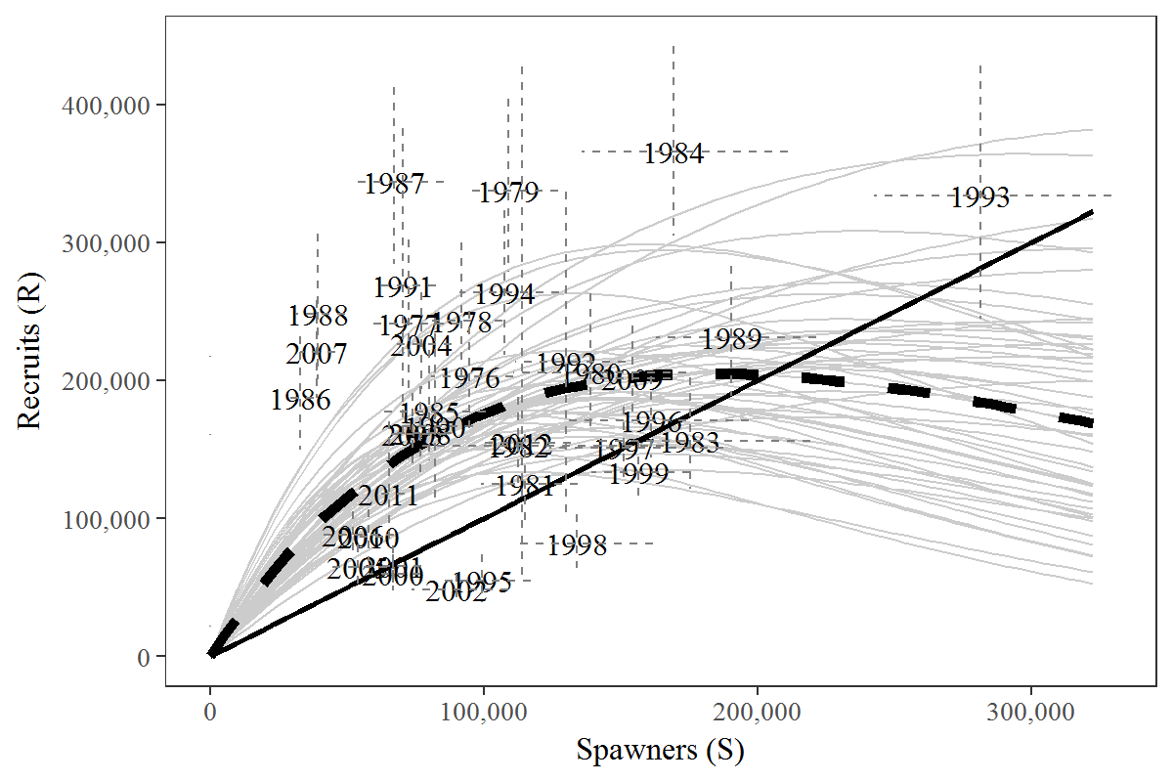

Figure 5.–Plausible spawner-recruit relationships for Chilkat Lake sockeye salmon as derived from an age-structured state-space model fitted to abundance, harvest, and age data for calendar years 1976–2016. Posterior medians of *R* and *S* are plotted as brood year labels with 95% credibility intervals plotted as dashed lines. The heavy dashed line is the Ricker relationship constructed from ln(*α*) and *β* posterior medians. Ricker relationships are also plotted (light grey lines) for 50 paired values of ln(*α*) and *β* sampled from the posterior probability distribution, representing plausible Ricker relationships that could have generated the observed data. Recruits replace spawners on the solid diagonal line.

Posterior medians of escapement leading to maximum sustained yield, *S*MSY and *S*MSY(Peterman),were 97,275 (95% CI: 66,413–231,148) and 97,497 (95% CI: 66,447–232,408), respectively (Figure 6). Given the diversity of plausible S–R relationships (Figure 5), it is important to choose

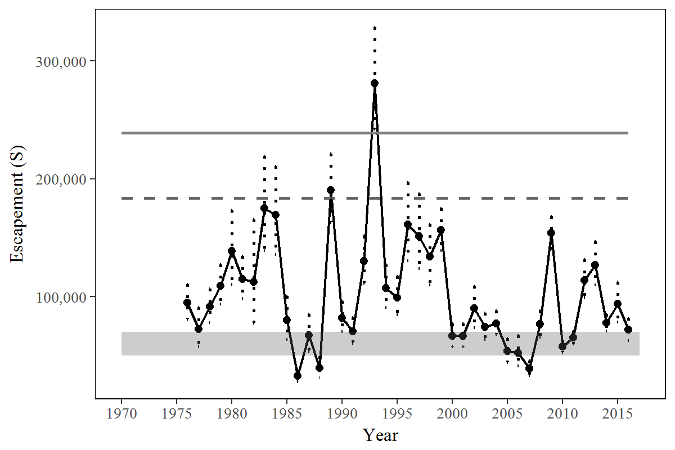

Figure 6.– Historical estimates of escapement and 95% credibility intervals (vertical dotted lines) for sockeye salmon obtained by fitting a state-space model to Chilkoot Lake sockeye salmon data, 1976–2016. Shaded areas bracket the recommended goal ranges. Posterior medians of *S*MSR (dotted line), and *S*EQ (solid line) are plotted as horizontal reference lines.

an escapement goal that is robust to this uncertainty rather than one tailored solely to the median S-R relationship. To address this uncertainty, the success or failure of a given number of spawners to achieve biological reference points across plausible S-R relationships are tallied to create optimal recruitment profiles (Figure 7; top panel), optimal yield profiles (Figure 7; middle panel), and overfishing profiles (Figure 7; bottom panel). Optimal recruitment profiles are the probabilities that a given spawning escapement will produce average recruitments exceeding 80% or 90% of maximum sustained recruitment. The profiles, which are highest near *S*MSR= 183,490 (Table 7), display the probability of achieving 80% and 90% of MSRfor specified levels of escapement. Optimal yield profiles show the probability of a given number of spawners achieving 80% and 90% of MSY. These probabilities, which are highest near *S*MSY, can be used to quantify the yield performance of prospective escapement goals (Figure 7; shaded areas), taking into consideration all of the uncertainty about the true abundance and productivity of the stock. Overfishing profiles show the probability that sustained yield would be reduced to less than 80% or 90% of MSYby fishing too hard and supplying too few spawners.

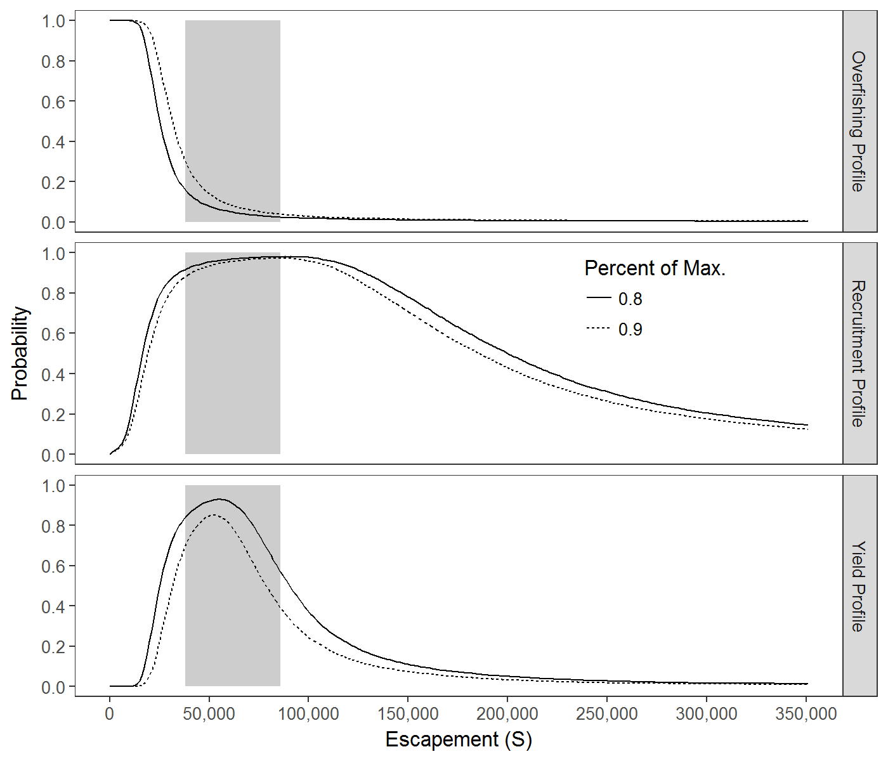

Figure 7.– Optimal recruitment profiles (ORPs), optimal yield profiles (OYPs), and overfishing profiles (OFPs) for Chilkoot Lake sockeye salmon. OYPs and ORPs show probability that a specified spawning abundance will result in specified fractions (80% and 90% line) of maximum sustained yield or maximum recruitment. OFPs show the probability that reducing escapement to a specified spawning abundance will result in less than specified fractions of maximum sustained yield. The shaded region shows the existing escapement goal range of 38,000-86,000.

Expected sustained yield or the numbers of fish over and above those necessary to replace spawners averaged over the brood years 1976–2010 is maximized near *S*MSY (Figure 8).

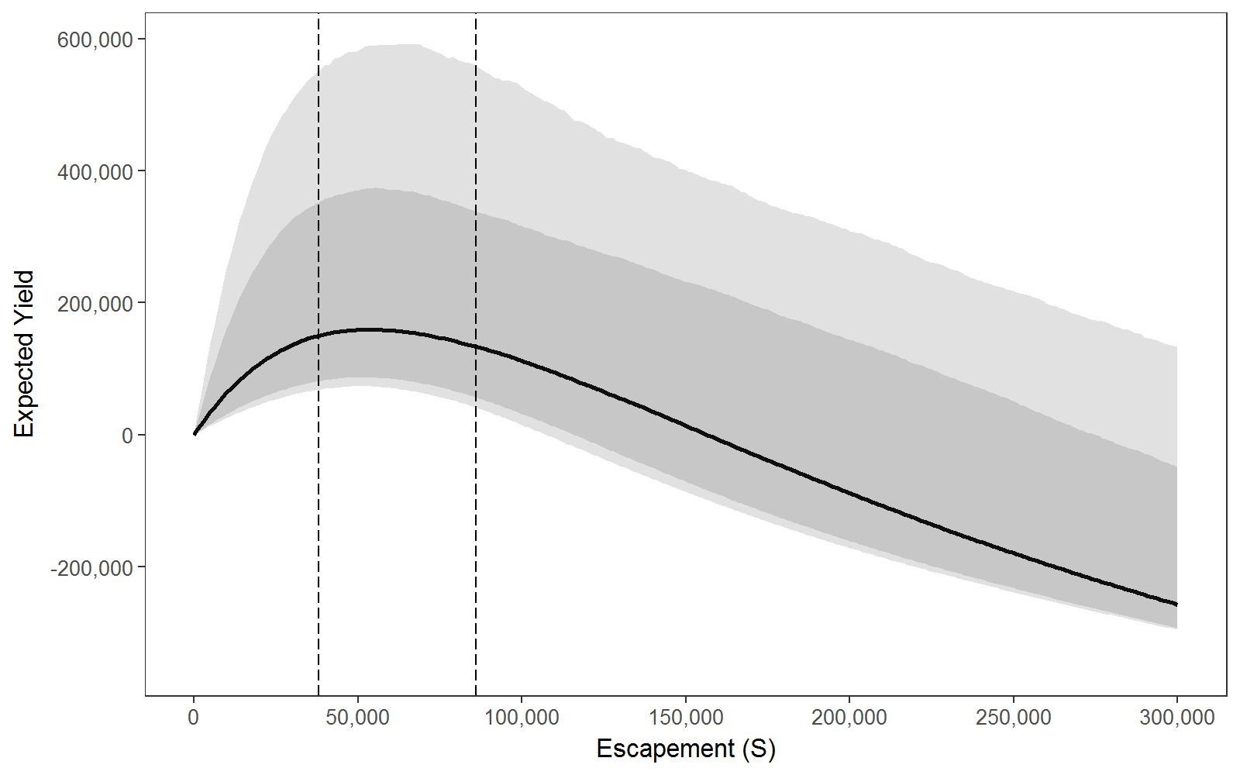

Figure 8.– Expected sustained yield (solid black line) and 90% and 95% credibility intervals (shaded areas) versus spawning escapement for Chilkoot Lake sockeye salmon. Dotted vertical lines bracket the recommended escapement goal range of 38,000–86,000.

# Discussion

Based on the autoregressive Ricker model, Eggers et al. (2009) recommended an SEG for Chilkoot Lake sockeye salmon of 38,000 to 86,000 spawners per year to be assessed with a weir at the Chilkoot River weir site. This goal range was the escapement range that produced 90% MSY as determined by the autoregressive Ricker model for the brood years 1976 to 2003 stock-recruit data. This study was similar in methodology to Eggers et al. (2010) in that a set of hierarchical stock-recruitment models that incorporated a first order autoregressive term and fry plant term were constructed and model comparisons were accomplished through a fit criteria. While Eggers et al. (2010) utilized the traditional stock-recruit analysis, a Bayesian model approach was employed in this study. In traditional stock recruit analysis, independence of individual quantities of spawners (*S*) and recruits (*R*) is assumed, and missing data must be imputed before the model is run. One advantage of the Bayesian state-space model is that missing data are no longer an issue. By correctly specifying annual age-structure in the Bayesian state-space model, missing data, like parameters, can be represented as unknown quantities for which posterior samples are generated. Additional uncertainty then flows through to the remaining model parameters as appropriate. Along with overcoming the issue of missing data, another advantage of the Bayesian age-structured state space model over traditional stock recruit methods is on obtaining good quality estimates of spawning abundance at maximum sustained yield(*S*MSY) in regards to bias reduction and interval coverage (Su and Peterman 2012).

Within the traditional framework, Eggers et al. (2010) was forced to rely on one escapement enumeration method per year, although overlapping escapement enumeration methods were available. Eggers et al. (2010) regressed mark-recapture estimates against weir counts for years with paired estimates, so that weir counts could be expanded to total escapement during years when mark-recapture experiments were not conducted. Thus, an uninterrupted time series of escapement was created for analysis. Within the Bayesian analysis state-space framework, we were able to incorporate multiple, overlapping methods of escapement enumeration within the models with allowances for missing data. Weir and mark-recapture data were considered independent measures of relative escapement that likely under-estimated and over-estimated escapement, respectively, while the DIDSON counts were treated as ‘true’ counts.

In addition to the limitations of missing data and multiple sources of data, traditional stock-recruit analysis does not fully consider the complexity introduced by age structure. Sockeye salmon return at multiple ages to spawn and maturity schedules can differ between cohorts. Estimates of age composition of the total run, weighted by the relative abundance of each component (harvest, escapement), are incorporated into the state-space model as data input. The model then predicts maturity-at-age and age composition of the total run.

Bayesian age-structured state-space models are becoming increasing common for the analysis of escapement goal ranges for Pacific salmon in Alaska (Fleischman and Reimer 2017; Hamazaki et al. (2012); Fleischman and McKinley (2013)). Sockeye salmon escapement goals were assessed in a Bayesian framework for Buskin River, Kodiak Island (Schmidt and Evans 2010), Speel Lake (Heinl et al. 2014), and the transboundary Alsek River and one of its tributaries, the Klukshu River (Eggers and Bernard 2011). A sustainable escapement goal (SEG) range of 5,000-8,000 would ensure sustained yield is within 90% of *S*MSY with 90% probability for the Buskin River. Optimum yield profiles and overfishing profiles showed that a biological escapement goal (BEG) range of 24,000 to 33,500 for the Alsek River has a 90–96% chance of attaining optimum yield escapements and that a biological escapement goal range of 7,500 to 11,000 has a 79–90% chance of attaining optimum yield for the Klukshu River. An SEG of 4,000–9,000 fish for Speel Lake sockeye salmon is based on the range of escapements estimated to provide greater than 70–80% of *S*MSY.

In Alaska, most salmon BEGs are developed using Ricker spawner-recruit models (Ricker 1954), and by definition in the *Policy for the Management of Sustainable Salmon Fisheries* (5AAC 39.222), BEG ranges are estimates of the number of spawners that provide the greatest potential for maximum sustained yield (*S*MSY). Eggers (1993) suggests that an escapement goal range from 0.8 to 1.6 times the *S*MSY will enable managers more flexibility to protect weak stocks and maintain sustainable catch levels of dominant stocks to within 90% of *S*MSY. Based on Eggers (2009), the escapement goal range of Chilkoot Lake sockeye salmon to the nearest 100 fish would be would be an SEG of 38,000 to 86,000. Eggers et al. (2009) recommended an SEG instead of a BEG due to a relatively high level of uncertainty of the weir counts. Across the state, BEGs that were set based on spawner-recruit analyses had an average lower bound escapement goal range that was 0.68 times *S*MSY and an upper bound escapement foal range that was 1.40 times *S*MSY (Appendix C).

# Escapement Goal Recommendation

At this time we recommend that the existing escapement goal for Chilkoot Lake sockeye salmon remain unchanged. Results from our revised analysis that used updated data in a Bayesian framework suggest that the existing goal of 38,000–86,000 spawners are quite close to the range of spawners that are likely to result in a high probability (>80%) of achieving at 90% or more of maximum sustained yield. Since 2012 there have been large escapements into Chilkoot Lake and the resulting recruits from these brood years could help to better define the current state of productivity and density dependence of this system. Thus, we suggest keeping the current escapement goal unchanged until these recruits can be enumerated and included in a revised spawner-recruitment model.

Finally, as has been done for other stocks in recent years, we recommend using a hierarchical age-structured state-space modeling approach in future analyses (Fleischman et al. 2013, Miller et al. *In Prep.*). Such an approach can incorporate multiple sources of data, for example mark-recapture estimates and weir counts, into escapement, harvest, and age composition……

# Acknowledgments

We would like to thank the many technicians and biologists who have helped to monitor and assess Chilkoot Lake sockeye salmon over the years, including those who have collected and read scales, operated weir and associated escapement projects. ……SPA, genetics, weir, mark-recapture,

# References Cited

[Akaike, H.](https://en.wikipedia.org/wiki/Hirotugu_Akaike) 1973. Information theory and an extension of the maximum likelihood principle, *in* Petrov, B.N.; Csáki, F., 2nd International Symposium on Information Theory, Tsahkadsor, Armenia, USSR, September 2-8, 1971, Budapest: Akadémiai Kiadó, pp. 267–281.

Arnason, A. N., C. W. Kirby, C. J. Schwarz, and J. R. Irvine. 1996. Computer analysis of data from stratified mark-recovery experiments for estimation of salmon escapements and other populations. Canadian Technical Report of Fisheries and Aquatic Sciences No. 2106.

Bachman, R. L., and A J. McGregor. 2001. Stock assessment studies of Chilkoot River adult salmon stocks in 1999. Alaska Department of Fish and Game, Division of Commercial Fisheries, Regional Information Report No. 1J01-36, Juneau.

Bachman, R. L. 2005. Stock assessment studies of Chilkoot River adult sockeye and chum salmon stocks in 2002. Alaska Department of Fish and Game, Fishery Data Series No. 05-36, Anchorage.

Bachman, R. L. 2010. Stock assessment studies of Chilkoot River adult sockeye and chum salmon stocks in 2003 and 2004. Alaska Department of Fish and Game, Fishery Data Series No. 10-23, Anchorage.

Bednarski, J. A., M. Sogge, and S. C. Heinl. 2016. Stock assessment study of Chilkoot Lake sockeye salmon, 2013–2015. Alaska Department of Fish and Game, Fishery Data Series No. 16-29, Anchorage.

Bergander, F. 1974. Southeastern Alaska sockeye salmon optimum escapement studies. Alaska Department of Fish and Game, Division of Commercial Fisheries, Anadromous Fish Conservation Act, Completion Report for period July 1, 1971 to June 30, 1974, AFC-40, Juneau.

Bergander, F. E., S. A. McPherson, and J. P. Koenings. 1988. Southeast Alaska sockeye salmon studies, 1987–1988. Technical Report for the period July 1, 1987, to June 30, 1988. Alaska Department of Fish and Game, Division of Commercial Fisheries, Regional Information Report No. 1J88-44, Juneau.

Bernard, D. R., and E. L. Jones III. 2010. Optimal escapement goals for Chinook salmon in the transboundary Alsek River. Alaska Department of Fish and Game, Fishery Manuscript Series No. 10-02, Anchorage.

Brooks, S.P. and Gelman, A., 1998. General methods for monitoring convergence of iterative simulations. Journal of computational and graphical statistics, 7(4):434-455.

Bugliosi, E. F. 1988. Hydrologic reconnaissance of the Chilkoot River basin. U.S. Geological Survey, Water-Resources Investigations Report 88-4023, Anchorage.

Eggers, D. M., and D. R. Bernard. 2011. Run reconstruction and escapement goals for Alsek River sockeye salmon. Alaska Department of Fish and Game, Fishery Manuscript Series No. 11-01, Anchorage.

Eggers, D. M., J. H. Clark, R. L. Bachman, and S. C. Heinl. 2008. Sockeye salmon stock status and escapement goals in Southeast Alaska. Alaska Department of Fish and Game, Special Publication No. 08-17, Anchorage.

Eggers, D. M., R. L. Bachman, and J. Stahl. 2010. Stock status and escapement goals for Chilkoot Lake sockeye salmon in Southeast Alaska. Alaska Department of Fish and Game, Fishery Manuscript No. 10-05, Anchorage.

**REFERENCES CITED (Continued)**

Evans, M., N. Hastings, and B. Peacock. 1993. Statistical Distributions. 2nd ed. Wiley and Sons, New York.

Fleischman, S. J., J. A. Der Hovanisian, and S. A. McPherson. 2011. Escapement goals for Chinook salmon in the Blossom and Keta rivers. Alaska Department of Fish and Game, Fishery Manuscript No. 11-05, Anchorage.

Fleischman, S. J., M. J. Catalano, R. A. Clark, and D. R. Bernard. 2013. An age-structured state-space stock–recruit model for Pacific salmon (*Oncorhynchus* spp.). Canadian Journal of Fisheries and Aquatic Sciences 70: 401–414.

Fleischman, S. J., and T. R. McKinley. 2013. Run reconstruction, spawner-recruit analysis, and escapement goal recommendation for late-run Chinook salmon in the Kenai River. Alaska Department of Fish and Game, Fishery Manuscript Series No. 13-02, Anchorage.

Fleischman, S. J., and A. M. Reimer. 2017. Spawner-recruit analyses and escapement goal recommendations for Kenai River Chinook salmon. Alaska Department of Fish and Game, Fishery Manuscript Series No. 17-02, Anchorage.

Geiger, H. J., R. L. Bachman, S. C. Heinl, K. Jensen, T. A. Johnson, A. Piston, and R. Riffe. 2005. Sockeye salmon stock status and escapement goals in Southeast Alaska [*in*] Der Hovanisian, J. A. and H. J. Geiger, editors. Stock status and escapement goals for salmon in Southeast Alaska 2005. Alaska Department of Fish and Game, Special Publication No. 05-22, Anchorage.

Gelman, A., J. B. Carlin, H. S. Stern, and D. B. Rubin. 2004. Bayesian Data Analysis. Chapman and Hall, Boca Raton.

Gilk-Baumer, S. E., S. D. Rogers Olive, D. K. Harris, S. C. Heinl, E. K. C. Fox, and W. D. Templin. 2015. Genetic mixed stock analysis of sockeye salmon harvests in selected northern Chatham Strait commercial fisheries, Southeast Alaska, 2012–2014. Alaska Department of Fish and Game, Fishery Data Series No. 15-03, Anchorage.

Harvey, A. C. 1989. Forecasting, Structural Time Series Models, and the Kalman Filter. Cambridge University Press, Cambridge, UK.

Hamazaki, T., M. Evenson, S. J. Fleischman, and K. L. Schaberg. 2012. Spawner-recruit analysis and escapement goal recommendations for Chinook salmon in the Kuskokwim River drainage. Alaska Department of Fish and Game, Fishery Manuscript Series No. 12-08, Anchorage.

Heinl, S. C., S. E. Miller, and J. A. Bednarski. 2014. Speel Lake sockeye salmon stock statusand escapement goal review. Alaska Department of Fish and Game, Fishery Manuscript SeriesNo. 14-04, Anchorage.

Ingledue, D. 1989. Hawk Inlet shore purse seine fishery, 1989. Alaska Department of Fish and Game, Division of Commercial Fisheries, Regional Information Report No. 1J89-31, Juneau.

Johnson, J., and M. Daigneault. 2013. Catalog of waters important for spawning, rearing, or migration of anadromous fishes – Southeastern Region, Effective July 1, 2013. Alaska Department of Fish and Game, Special Publication No. 13-09, Anchorage.

**REFERENCES CITED (Continued)**

Kelley, M. S., and R. L. Bachman. 2000. Stock assessment studies of the Chilkoot River adult salmon stocks in 1998. Alaska Department of Fish and Game, Division of Commercial Fisheries, Regional Information Report No. 1J00-29, Juneau.

Koenings, J. P., and R. D. Burkett. 1987. The population characteristics of sockeye salmon (*Oncorhynchus nerka*) smolts relative to temperature regimes, euphotic volume, fry density, and forage base within Alaskan lakes. p. 216–234 [*in]* H. D. Smith, L. Margolis, and C. C. Wood. [editors]. Sockeye salmon (*Oncorhynchus nerka*) population biology and future management. Special Publication of the Canadian Journal of Fisheries and Aquatic Sciences No. 96.

Marshall, S. L., S. A. McPherson, and S. Sharr. 1982. Origins of sockeye salmon (*Oncorhynchus nerka*) in the Lynn Canal drift gillnet fishery of 1981 based on scale pattern analysis. Alaska Department of Fish and Game, Technical Data Report No. 75, Juneau.

McPherson, S. A., and S. L. Marshall. 1986. Contribution, exploitation, and migratory timing of Chilkoot and Chilkoot river runs of sockeye salmon (*Oncorhynchus nerka*) in the Lynn Canal drift gillnet fishery of 1983. Alaska Department of Fish and Game, Division of Commercial Fisheries, Technical Data Report No. 165, Juneau.

McPherson, S. A. 1987a. Contribution, exploitation, and migratory timing of Chilkoot and Chilkoot river runs of sockeye salmon (*Oncorhynchus nerka*) in the Lynn Canal drift gillnet fishery of 1984. Alaska Department of Fish and Game, Division of Commercial Fisheries, Technical Data Report No. 198, Juneau.

McPherson, S. A. 1987b. Contribution, exploitation, and migratory timing of returns of sockeye salmon (*Oncorhynchus nerka*) stocks to Lynn Canal in 1985 based on analysis of scale patterns. Alaska Department of Fish and Game, Division of Commercial Fisheries, Technical Data Report No. 217, Juneau.

McPherson, S. A. 1989. Contribution, exploitation, and migratory timing of Lynn Canal sockeye salmon runs in 1987 based on analysis of scale patterns. Alaska Department of Fish and Game, Division of Commercial Fisheries, Regional Information Report No. 1J89-18, Juneau.

McPherson, S. A. 1990. An in-season management system for sockeye salmon returns to Lynn Canal, southeast Alaska. M. S. Thesis, University of Alaska, Fairbanks.

McPherson, S. A., and E. L. Jones. 1987. Contribution, exploitation, and migratory timing of sockeye salmon stocks to Lynn Canal in 1986 based on analysis of scale patterns. Alaska Department of Fish and Game, Division of Commercial Fisheries, Technical Data Report No. 220, Juneau.

McPherson, S. A., and M. A. Olsen. 1992. Contribution, exploitation, and migratory timing of Lynn Canal sockeye salmon runs in 1989 based on analysis of scale patterns. Alaska Department of Fish and Game, Division of Commercial Fisheries, Technical Fishery Report No. 92-22, Juneau.

**REFERENCES CITED (Continued)**

McPherson, S. A., F. E. Bergander, M. A. Olsen, and R. R. Riffe. 1992. Contribution, exploitation, and migratory timing of Lynn Canal sockeye salmon runs in 1988 based on analysis of scale patterns. Alaska Department of Fish and Game, Division of Commercial Fisheries, Technical Fishery Report No. 92-21, Juneau.

Millar, R. B. 2002. Reference priors for Bayesian fisheries models. Canadian Journal of Fisheries and Aquatic Sciences 59:1492-1502.

Munro, A. R., and E. C. Volk. 2016. Summary of Pacific salmon escapement goals in Alaska with a review of escapements from 2007 to 2015. Alaska Department of Fish and Game, Fishery Manuscript Series No. 16-04, Anchorage.

Noakes, D., D. W. Welch, and M. Stocker. 1987. A time series approach to stock-recruitment analysis: transfer function noise modeling. Natural Resource Modeling 2:213–233.

Parken, C.K., R.E. McNicol, and J.R. Irvine. 2006. Habitat-based methods to estimate escapement goals for data limited Chinook salmon stocks in British Columbia, 2004. Fisheries and Oceans Canada, Canadian Scientific Advisory Secretariat Research Document 2006/083.

Peterman, R. M., B. J. Pyper, and J. A. Grout. 2000. Comparison of parameter estimation methods for detecting climate-induced changes in productivity of Pacific salmon (*Oncorhynchus* spp.). Canadian Journal of Fisheries and Aquatic Sciences 57:181–191.

Plummer, M. 2016. rjags: Bayesian Graphical Models using MCMC. R package version 4-6. <https://CRAN.R-project.org/package=rjags>

R Core Team 2016. R: A language and environment for statistical computing. R Foundation for Statistical Computing, Vienna, Austria. URL https://www.R-project.org/.

Rich, W. H., and E. M. Ball. 1933. Statistical review of the Alaska salmon fisheries. Part IV: Southeastern Alaska. Bulletin of the Bureau of Fisheries, Vol. XLVII (47), No. 13: 437–673.

Ricker, W. E. 1954. Stock and recruitment. Journal of the Fisheries Research Board of Canada 11:559–623.

Schmidt, J., D. Evans and D. Tracy. 2006. Stock assessment of sockeye salmon of the Buskin River, 2000-2003. Alaska Department of Fish and Game, Fishery Data Series No.

05-69, Anchorage.

Schwarz, Gideon E. 1978. Estimating the dimension of a model. [Annals of Statistics](https://en.wikipedia.org/wiki/Annals_of_Statistics), 6 (2): 461–464.

Sogge, M. M., and R. L. Bachman. 2014. Operational Plan: Stock assessment studies of Chilkoot River adult salmon. Alaska Department of Fish and Game, Regional Operational Plan ROP.CF1J.14-03, Douglas.

Spiegelhalter, D.J., Best, N.G., Carlin, B.P. and Van Der Linde, A., 2002. Bayesian measures of model complexity and fit. Journal of the Royal Statistical Society: Series B (Statistical Methodology), 64(4): 583-639.

**REFERENCES CITED (Continued)**

Stockley, C. 1950. The sockeye salmon of Chilkoot and Chilkoot inlets. Fisheries Research Institute Paper No 286, University of Washington, Seattle.

Su, Z., and R. M. Peterman. 2012. Performance of a Bayesian state-space model of semelparous species for stock-recruitment data subject to measurement error. Ecological Modelling 224:76–89.

Toft, N., Innocent, G.T., Gettinby, G. and Reid, S.W., 2007. Assessing the convergence of Markov Chain Monte Carlo methods: an example from evaluation of diagnostic tests in absence of a gold standard. Preventive veterinary medicine, 79(2):244-256.

# APPENDICES

Appendix A.–RJAGS model code for the Bayesian MCMC analysis of the Chilkoot Lake sockeye salmon model, 1976–2016 can be found at the ADF&G GitHub site, located here: <https://github.com/commfish/AlaskaSalmon>. Please contact the authors of this report if you have problems opening this link or have questions or suggestion regarding the analysis.

Appendix B.–RJAGS data objects for the Bayesian MCMC statistical analysis of the Chilkoot Lake sockeye salmon data run reconstruction model, 1976–2016. The multinomial age counts (x) may not sum exactly to the effective sample size of 100 due to rounding. Y is the number of calendar years, A is the number of age classes, and C is the number of cohorts represented in the data (C=Y+A-1). In the table, ‘DS’ are the DIDSON escapement counts with associated coefficient of variations (DS.cv), ‘weir’ are the weir escapement counts with associated coefficient of variations (weir.cv), ‘mr’ are the mark–recapture escapement counts with the associated coefficient of variations (mr.cv), and ‘Hbelow’ is the total harvest with associated coefficient of variations (Hbelow.cv).

|  |  |  |  |  |  |  |  |  |  |  |  |
| --- | --- | --- | --- | --- | --- | --- | --- | --- | --- | --- | --- |
| Year | DS | DS.cv | mr | mr.cv | weir | weir.cv | Hbelow | Hbelow.cv | x4 | x5 | x6 |
| 1976 | NA | 0.90 | NA | 0.90 | 69,729 | 0.05 | 58,765 | 0.20 | 5 | 67 | 27 |
| 1977 | NA | 0.90 | NA | 0.90 | 50,363 | 0.10 | 41,477 | 0.20 | 3 | 75 | 22 |
| 1978 | NA | 0.90 | NA | 0.90 | 67,528 | 0.05 | 89,558 | 0.20 | 6 | 64 | 30 |
| 1979 | NA | 0.90 | NA | 0.90 | 80,588 | 0.05 | 115,995 | 0.20 | 2 | 78 | 20 |
| 1980 | NA | 0.90 | NA | 0.90 | 101,135 | 0.10 | 31,267 | 0.20 | 2 | 62 | 36 |
| 1981 | NA | 0.90 | NA | 0.90 | 84,097 | 0.05 | 48,420 | 0.20 | 1 | 55 | 44 |
| 1982 | NA | 0.90 | NA | 0.90 | 86,213 | 0.20 | 127,174 | 0.20 | 3 | 50 | 47 |
| 1983 | NA | 0.90 | NA | 0.90 | 134,601 | 0.10 | 124,180 | 0.20 | 5 | 55 | 40 |
| 1984 | NA | 0.90 | NA | 0.90 | 123,190 | 0.10 | 99,592 | 0.20 | 2 | 73 | 25 |
| 1985 | NA | 0.90 | NA | 0.90 | 58,335 | 0.10 | 131,091 | 0.20 | 2 | 38 | 60 |
| 1986 | NA | 0.90 | NA | 0.90 | 23,947 | 0.05 | 168,006 | 0.20 | 2 | 36 | 62 |
| 1987 | NA | 0.90 | NA | 0.90 | 48,972 | 0.10 | 69,900 | 0.20 | 3 | 60 | 37 |
| 1988 | NA | 0.90 | NA | 0.90 | 27,722 | 0.10 | 76,883 | 0.20 | 2 | 44 | 54 |
| 1989 | NA | 0.90 | NA | 0.90 | 141,475 | 0.05 | 156,160 | 0.20 | 1 | 70 | 30 |
| 1990 | NA | 0.90 | NA | 0.90 | 60,230 | 0.05 | 149,377 | 0.20 | 1 | 44 | 55 |
| 1991 | NA | 0.90 | NA | 0.90 | 51,138 | 0.05 | 60,721 | 0.20 | 2 | 46 | 52 |
| 1992 | NA | 0.90 | NA | 0.90 | 95,880 | 0.05 | 113,146 | 0.20 | 1 | 44 | 55 |
| 1993 | NA | 0.90 | NA | 0.90 | 212,757 | 0.05 | 103,531 | 0.20 | 3 | 38 | 59 |
| 1994 | NA | 0.90 | 153,540 | 0.1 | 86,385 | 0.10 | 126,852 | 0.20 | 2 | 57 | 41 |
| 1995 | NA | 0.90 | 184,541 | 0.1 | 61,783 | 0.10 | 68,737 | 0.20 | 4 | 46 | 50 |
| 1996 | NA | 0.90 | 262,852 | 0.1 | NA | 0.05 | 99,677 | 0.20 | 0 | 0 | 0 |
| 1997 | NA | 0.90 | 238,803 | 0.1 | NA | 0.05 | 73,761 | 0.20 | 0 | 0 | 0 |
| 1998 | NA | 0.90 | 211,114 | 0.09 | NA | 0.05 | 112,630 | 0.20 | 0 | 0 | 0 |
| 1999 | NA | 0.90 | 240,002 | 0.05 | 134,048 | 0.10 | 149,410 | 0.20 | 1 | 43 | 55 |
| 2000 | NA | 0.90 | 132,687 | 0.12 | 47,077 | 0.05 | 78,265 | 0.20 | 2 | 13 | 85 |
| 2001 | NA | 0.90 | 105,064 | 0.07 | 53,239 | 0.20 | 60,183 | 0.20 | 3 | 78 | 20 |
| 2002 | NA | 0.90 | 148,465 | 0.17 | 65,611 | 0.10 | 47,332 | 0.20 | 3 | 45 | 52 |
| 2003 | NA | 0.90 | 116,891 | 0.07 | 55,516 | 0.20 | 49,955 | 0.20 | 2 | 29 | 68 |
| 2004 | NA | 0.90 | 118,795 | 0.06 | 83,534 | 0.20 | 51,110 | 0.20 | 5 | 67 | 29 |
| 2005 | NA | 0.90 | 89,072 | 0.10 | 32,098 | 0.20 | 22,852 | 0.20 | 3 | 37 | 59 |
| 2006 | NA | 0.90 | 91,439 | 0.17 | 38,850 | 0.20 | 15,979 | 0.20 | 6 | 59 | 35 |
| 2007 | NA | 0.90 | 59,884 | 0.10 | 27,915 | 0.10 | 14,208 | 0.20 | 5 | 53 | 41 |
| 2008 | 74,919 | 0.10 | 119,808 | 0.11 | NA | 0.05 | 22,156 | 0.20 | 5 | 82 | 13 |
| 2009 | 153,033 | 0.05 | 285,218 | 0.13 | NA | 0.05 | 85,551 | 0.20 | 2 | 64 | 34 |
| 2010 | 61,906 | 0.05 | 72,318 | 0.09 | NA | 0.05 | 48,079 | 0.20 | 3 | 32 | 66 |
| 2011 | 63,628 | 0.05 | 109,335 | 0.08 | NA | 0.05 | 15,599 | 0.20 | 8 | 61 | 30 |
| 2012 | 121,810 | 0.10 | 171,924 | 0.10 | NA | 0.05 | 54,884 | 0.20 | 6 | 75 | 19 |
| 2013 | 116,300 | 0.10 | 224,516 | 0.10 | NA | 0.05 | 75,588 | 0.20 | 6 | 50 | 44 |
| 2014 | 70,470 | 0.05 | 212,201 | 0.12 | NA | 0.05 | 81,502 | 0.20 | 4 | 67 | 29 |
| 2015 | 175,874 | 0.20 | 124,892 | 0.10 | NA | 0.05 | 33,085 | 0.20 | 4 | 30 | 66 |
| 2016 | 88,513 | 0.10 | 96,148 | 0.09 | NA | 0.05 | 35,991 | 0.20 | 4 | 58 | 37 |

Appendix C.– Escapement goals for the Southeast Region, Central Region (Upper Cook Inlet Prince William Sound), Arctic-Yukon-Kuskokwim (AYK) Region, Westward Region (Alaska Peninsula/Aleutian Islands, Kodiak). This table is modified from Munro and Volk 2016. The lower bound (LB) and upper bound (UB) percentages show the change from the LB and UB to the *S*MSY value.

|  |  |  |  |  |  |  |  |  |  |
| --- | --- | --- | --- | --- | --- | --- | --- | --- | --- |
| Area | System | *S*MSY | LB | UB | Type | Initial Year | LB% | UB% | Sources |
| Southeast | Tahltan Lake | 24,000 | 18,000 | 30,000 | BEG | 1993 | 75% | 125% | Humphreys et al. 1994; TTC 1993 |
| Southeast | Redoubt Lake | 17,400 | 10,000 | 25,000 | BEG | 2003 | 57% | 144% | Geiger 2003 |
| Southeast | Chilkoot Lake | 105,000 | 70,000 | 150,000 | BEG | 2009 | 67% | 143% | Eggers et al. 2010 |
| Southeast | East Alsek-Doame River | 16,000 | 13,000 | 26,000 | BEG | 2003 | 81% | 163% | Clark et al. 2003 |
| Southeast | Klukshu River | 9,102 | 7,500 | 11,000 | BEG | 2013 | 82% | 121% | Eggers and Bernard 2011 |
| Southeast | Alsek River | 28,190 | 24,000 | 33,500 | BEG | 2013 | 85% | 119% | Eggers and Bernard 2011 |
| Southeast | Situk River | 50,000 | 30,000 | 70,000 | BEG | 2003 | 60% | 140% | Clark et al. 2002 |
| Upper Cook Inlet | Kasilof River | 240,000 | 160,000 | 340,000 | BEG | 2011 | 67% | 142% | Fair et al. 2010 |
| Upper Cook Inlet | Russian River - Early Run | 36,255 | 22,000 | 42,000 | BEG | 2011 | 61% | 116% | Fair et al. 2010 |
| Prince William Sound | Eshamy Lake | 19,622 | 13,000 | 28,000 | BEG | 2009 | 66% | 143% | Fair et al. 2008 |
| Kuskokwim Area | Middle Fork Goodnews River | 21,890 | 18,000 | 40,000 | BEG | 2007 | 82% | 183% | Brannian et al. 2006; Molyneaux and Brannian 2006 |
| AK Peninsula | Nelson River | 153,000 | 97,000 | 219,000 | BEG | 2004 | 63% | 143% | Nelson et al. 2006 |
| Kodiak | Afognak (Litnik) River | 34000 | 20,000 | 50,000 | BEG | 2005 | 59% | 147% | Nelson et al. 2005 |
| Kodiak | Karluk River Early Run | 175,000 | 110,000 | 250,000 | BEG | 2008 | 63% | 143% | Honnold et al. 2007a |
| Kodiak | Karluk River Late Run | 266,000 | 170,000 | 380,000 | BEG | 2005 | 64% | 143% | Nelson et al. 2005 |
| Kodiak | Upper Station River Early Run | 66,000 | 43,000 | 93,000 | BEG | 2011 | 65% | 141% | Nemeth et al. 2010 |
| Kodiak | Upper Station River Late Run | 186,000 | 120,000 | 265,000 | BEG | 2005 | 65% | 142% | Nelson et al. 2005 |
| Kodiak | Frazer Lake | 118,000 | 75,000 | 170,000 | BEG | 2008 | 64% | 144% | Honnold et al. 2007a |
| Kodiak | Saltery Lake | 23,600 | 15,000 | 35,000 | BEG | 2011 | 64% | 148% | Nemeth et al. 2010 |
| Kodiak | Buskin Lake | 6,650 | 5,000 | 8,000 | BEG | 2011 | 75% | 120% | Nemeth et al. 2010 |
| Average |  |  |  |  |  |  | 68% | 140% |  |